THE PUNJAB ENFORCEMENT AND REGULATORY AUTHORITY (APPOINTMENT AND CONDITIONS OF SERVICE) (AMENDED) REGULATIONS, 2025
CONTENTS

- Short Title and Commencement
- Definitions
- Appointment and Conditions of Service
- Terms of Reference of Service
- Eligibility for Appointment
- Initial Recruitment
- Probation, Training and Departmental Examination
- Transfer and Posting
- Promotion
- Seniority
- Resignation
- Retirement
- Deputation
- Recruitment Committees and Deputationist Screening Panels
- Exemptions and Relaxations
- General Provisions
- Repeal
- Savings

SCHEDULES
- Schedule-I - Organizational Structure
- Schedule-II - Appointment & Conditions of Service
- Schedule-III - Terms of Reference of Service
- Schedule-IV - Rules / Regulations Adopted by the Authority
- Schedule-V - Transfer and Posting
- Schedule-VI - Special Allowance and Benefits



GOVERNMENT OF THE PUNJAB
PUNJAB ENFORCEMENT AND REGULATORY AUTHORITY
Lahore, Dated the 12th November, 2025

THE PUNJAB ENFORCEMENT AND REGULATORY AUTHORITY (APPOINTMENT AND CONDITIONS OF SERVICE) (AMENDED) REGULATIONS, 2025

NOTIFICATION
No.DG(PERA)/1-1/2025(SRs).- In exercise of the powers conferred under Section 79 read with Section 11 of the Punjab Enforcement and Regulation Act, 2024 and Rule 3 of the Punjab Enforcement and Regulatory Authority Rules, 2024, the Authority is pleased to make the following Regulations:
1. Short title and Commencement. - (1) These Regulations may be cited as the Punjab Enforcement and Regulatory Authority (Appointment and Conditions of Service) (Amended) Regulations, 2025 and shall be published in the official gazette of Government of the Punjab.
(2) These Regulations shall come into force at once.
2. Definitions. - (1) In these Regulations, unless the context otherwise requires, the following expressions shall have the meanings hereby respectively assigned to them, that is to say:
- “Act” means the Punjab Enforcement and Regulation Act, 2024 (Act XI of 2024);
- “Administrative Department / AD” means the administrative department of the Authority as reflected in the Punjab Government Rules of Business, 2011;
- “Appointing Authority” means the authority as mentioned in the column 3 of Schedule-II;
- “Buddy System" means a safety protocol that pairs two or more officers / officials during performance of enforcement and regulatory operations;
- “Contingent Paid Staff" means a person who is temporarily hired by the Directorate General or the Sub-Divisional Enforcement Officer for a period of maximum 89 days on latest minimum wage rate notified by Government of the Punjab, for performance of general duties;
- “Contractual Employees” means an employee, staff or any other person recruited by the Authority through competitive process from the market on contractual basis as per the terms of reference for service and are governed by “the Punjab Enforcement and Regulatory Authority (Appointment and Conditions of Service for Contractual Employees) Regulations, 2025” and mentioned in these Regulations to the extent of organizational structure only;
- “Directorate General” means responsible for management and supervision of different wings of PERA under the Director General, PERA as provided in Section 2 (1) (l) and Section 8 of the Act;
- “Employee” means an Officer, staff or any other person recruited by the Authority under Section 11 of the Act, but does not include a person on deputation to the Service or the Contingent Paid Staff;
- “Initial recruitment” means the appointment made other than by promotion or transfer of the employees; from any other service / department;
- “Law Enforcement Agency / LEA” means employees of the Punjab Police and/or any other agency or body approved as such by the Authority;
- “Medical Board”, means a medical board as notified by the Director General for the purposes of initial recruitment, promotion and general medical fitness as and when required;
- “Organizational Structure” means the organizational structure given in Schedule-I of these Regulations and includes employees, contractual employees and the Contingent Paid Staff;
- “Recognized University” means any University incorporated through an Act of the Parliament of Pakistan or the Provincial Assembly concerned or any other University declared as such by the Government, in consultation with the Higher Education Commission of Pakistan, to be a recognized University;
- “Recruitment Committee” means the Committee(s) notified by the Director General, PERA which shall have composition, TORs and functions as defined in Regulation 14 of these Regulations.
- “Regulations” mean the Punjab Enforcement and Regulatory Authority (Appointment and Conditions of Service) Regulations, 2025;
- “Service” means the service of a person serving in Punjab Enforcement and Regulatory Authority;
- “Schedule” means the Schedule appended to the Regulations;
- “Terms of Reference for Service”, means purpose of employee, his / her job description, area of responsibility, competence, qualification, personal attributes and pay & allowances as detailed in the relevant Schedule;
- “Wing” means a group of posts in Authority pertaining to one particular area of responsibility.
(2) A word or expression used in these Regulations but not defined shall have the same meaning as assigned to it under the Act or other notified Regulations of the Authority.
- Appointment and Conditions of Service. – Appointment and Conditions of Service shall include but not limited to the nomenclature of the post, appointing authority, minimum qualification, method of appointment and other terms and conditions as specified in Schedule-II.
- Terms of Reference of Service. – The terms of reference of service for an employee shall be as specified in Schedule–III.
- Eligibility for Appointment. – (1) Subject to the provisions contained herein, a person shall be eligible for appointment in the Service, provided that:
    - He is domiciled in Punjab and fulfills the terms and conditions given in Schedule-II and the terms of reference of service given in Schedule-III;
    - He is declared fit by the Medical Board;
    - His character and antecedents are duly verified;
    - He submits a declaration to the effect that he is married / not married to any foreign national, on the format finalized by the Director General and he undertakes to inform the Authority if he marries any foreign national, in future.
(2) All appointments shall be governed as per provisions of the Punjab Enforcement and Regulation Act, 2024, Punjab Enforcement and Regulatory Authority Rules, 2024, Punjab Enforcement and Regulatory Authority (Performance Appraisal) Regulations, 2025, Punjab Enforcement and Regulatory Authority (Efficiency & Discipline) Regulations, 2025, Punjab Enforcement and Regulatory Authority (Operations & Procedures) Rules, 2025, Punjab Enforcement and Regulatory Authority (Human Resource) Manual, 2025, and Punjab Enforcement and Regulatory Authority (Training) Manual, 2025, as amended from time to time as well as any other applicable regulations, SOPs, guidelines and instructions issued by the Government, the Authority or the Directorate General, as the case may be, from time to time.
(3) The Authority may require the appointees to submit Service / Surety Bond, for the amount and period of its pleasure, on the prescribed format, to the effect that they shall be bound to repay the amount if they resign or absent themselves from duties, without authorization, during the stipulated period.
(4) The Director General may waive the Service / Surety Bond condition, if special circumstances exist, by recording the reasons in writing.
- Initial Recruitment. - Initial recruitment shall be made by the respective Appointing Authorities on the recommendations of the respective Recruitment Committees or the Punjab Public Service Commission, as the case may be, as per Schedules appended hereunder.
- Probation, Training and Departmental Examination. - (1) Employees appointed through initial recruitment shall remain on probation for a period of one year, provided that the Appointing Authority may extend the period of probation for another year, not further extendable.
(2) No employee shall be confirmed in the Service unless he has successfully completed such training, probation and qualified the departmental examination, as may be required.
(3) The Service shall be liable to be terminated during the initial or extended period of probation, after serving one notice and hearing before the competent authority or the authorized officer, as the case may be.
- Transfer and Posting. – (1) The employee shall be liable to be transferred and posted anywhere in Punjab, as per requirements determined by the competent authority.
(2) Competent authorities for transfer and posting of employees shall be as given in Schedule-V.
- Promotion. – (1) The employees shall be promoted on the recommendations of the relevant Promotion Committee(s) notified by the Director General.
(2) The Director General shall notify the department promotion committee(s) and the promotion criteria in pursuance of section 81 of the Act and these regulations.
- Seniority. - (1) The inter-se-seniority of employees shall be determined as follows:
  - in accordance with the date of regular appointment in the grade, those appointed earlier to rank shall be higher in seniority to those appointed later;
  - in accordance with merit where the date of recommendation from the Recruitment Committee or the Punjab Public Service Commission is the same, the higher in merit to rank shall be higher in seniority than those lower in merit;
  - in accordance with the age of the appointee where two or more persons are appointed on the same date or have the same merit, whereby the older shall be senior to the younger;
  - The Director General shall notify final seniority lists of the employees, in accordance with the Regulations, from time to time, which shall be determined after giving effect of the cumulative merit calculated on the basis of marks and grades communicated by the Punjab Public Service Commission or the Recruitment Committee, as the case may be, and marks and grades secured by the employees upon completion of mandatory training.
- Resignation. - (1) An employee may resign from the Service by giving one month’s notice in writing or one month’s pay in lieu thereof provided he has cleared all requisite liabilities.
(2) Notwithstanding anything and without prejudice to the above, the Director General may, if the employee so requests, waive the notice period requirement for acceptance of resignation, on the basis of special circumstances to be recorded in writing.
- Retirement. - (1) An employee shall stand retired from the service in accordance with the relevant general rules or policies issued by the Government.
(2) In case of failure to maintain the requisite medical and physical fitness, he shall be discharged or retired from the Service by the competent authority as per applicable rules and regulations.
- Deputation. - The employees joining the Authority on deputation shall be governed as per Deputation Policy of the Government. Such employees shall be screened by the Deputationist Screening Panels concerned to ensure that they meet the terms of reference of service. The Authority may approve any exception to the Deputation Policy, for the employees serving in the Authority, on deputation basis.
- Recruitment Committees and Deputationist Screening Panels. - (1) Subject to provisions of these Regulations, there shall be following Recruitment Committees:
  - Recruitment Committee-1.
For recruitment of employees of BS-11 and above:
      - Director General, PERA - Chairman
      - Additional DG (Admin. & HR), PERA - Member
      - Additional DG (M&I), PERA - Member
      - CTO, PERA - Member
      - Rep. of the AD, not below BS-18 - Member
      - DD (Adm. & HR), PERA - Member/Secretary
      - Any other co-opted Member to be nominated by the Director General.
  - Recruitment Committee-2. For recruitment of employees of BS-10 and below, the District Enforcement and Regulatory Board, as provided in section 12 of the Act, shall function as the Recruitment Committee-2.
  - Recruitment Committee-3. The following Committee shall be authorized to engage services of Contingent Paid Staff for performance of temporary duties at the Directorate General of PERA, on daily wage basis:
- Additional DG (Admin. & HR), PERA - Chairman
- Deputy Director (Admin. & HR), PERA - Member

  - Recruitment Committee-4. The following Committee shall be authorized to engage services of Contingent Paid Staff for performance of temporary duties at the Enforcement Stations, on daily wage basis:
- SDEO concerned - Chairman
- An EO, as nominated by SDEO - Member
- An SSO, as nominated by SDEO - Member
  - TORs / Functions of Recruitment Committees
- Conduct and supervise the recruitment process.
- Approve and oversee the advertisement of positions through appropriate platforms.
- Scrutinize received applications to ensure completeness and eligibility.
- Shortlist candidates in a transparent and merit-based manner on the basis of predefined criteria.
- Document reasons for acceptance or rejection of applications.
- Ensure integrity, confidentiality, impartiality, and fairness of the recruitment process.
- Recommend appointment including justifications for selection, and reserves or waitlists, if advised.
- Meetings of the Committees shall be convened as per requirement.
- Quorum shall consist of a minimum of three members including the Chairpersons or their nominees.
(2) In addition to the recruitment functions, the Recruitment Committee-1 and the Recruitment Committee-2 shall also function as Deputationist Screening Panels in line with the terms of reference of service for employees of BS-11 and above and BS-10 and below, respectively.
(3) The Director General may hire the services of consultant(s) / expert(s) of the relevant field(s) or agency for the purposes of selection of most suitable and competent human resource, subject to observance of the Punjab Procurement Rules, 2014.
(4) The Authority may entrust the recruitment process of any of its positions to the Punjab Public Service Commission, with prior approval of the Chief Minister, Punjab, as provided in the Recruitment Policy, 2022. However, the Authority may take exception of any of the provisions of the Policy ibid, for efficient and effective implementation of the Act and the Regulations.
- Exemptions and Relaxations. – The Authority, on the recommendation by the Director General, may exempt or relax any of the provision(s) of these Regulations, for the sake of effective administration.
- General Provisions. – (1) In all matters not expressly provided for in these Regulations, such matters shall be governed by the relevant rules, regulations, policies, and guidelines issued by the Government including the rules and policies adopted by the Authority as given in Schedule-IV.
(2) The employees shall be bound to participate in such Pension Scheme and / or medical policy as introduced by the Authority.
(3) The Director General may define, redefine, alter, or modify the reporting channels for and assign special tasks to the employees appointed at the Directorate General, as per operational requirements and administrative efficiency and discipline.
- Overriding Effect: The provisions of these regulations shall have overriding effect notwithstanding anything inconsistent therewith contained in any other rules, regulations or manual for the time being in force.
- Repeal: The Punjab Enforcement and Regulatory Authority (Appointment and Conditions of Service) Regulations, 2025 are hereby repealed from the date of notification of these Regulations in the official gazette of the Government; and no vested right shall be affected by such repeal.

- Savings: All acts done, decisions made, and actions taken including appointments and contracts made under the Punjab Enforcement and Regulatory Authority (Appointment and Conditions of Service) Regulations, 2025 shall remain intact unless specifically altered, repealed, or amended.

Schedule-II
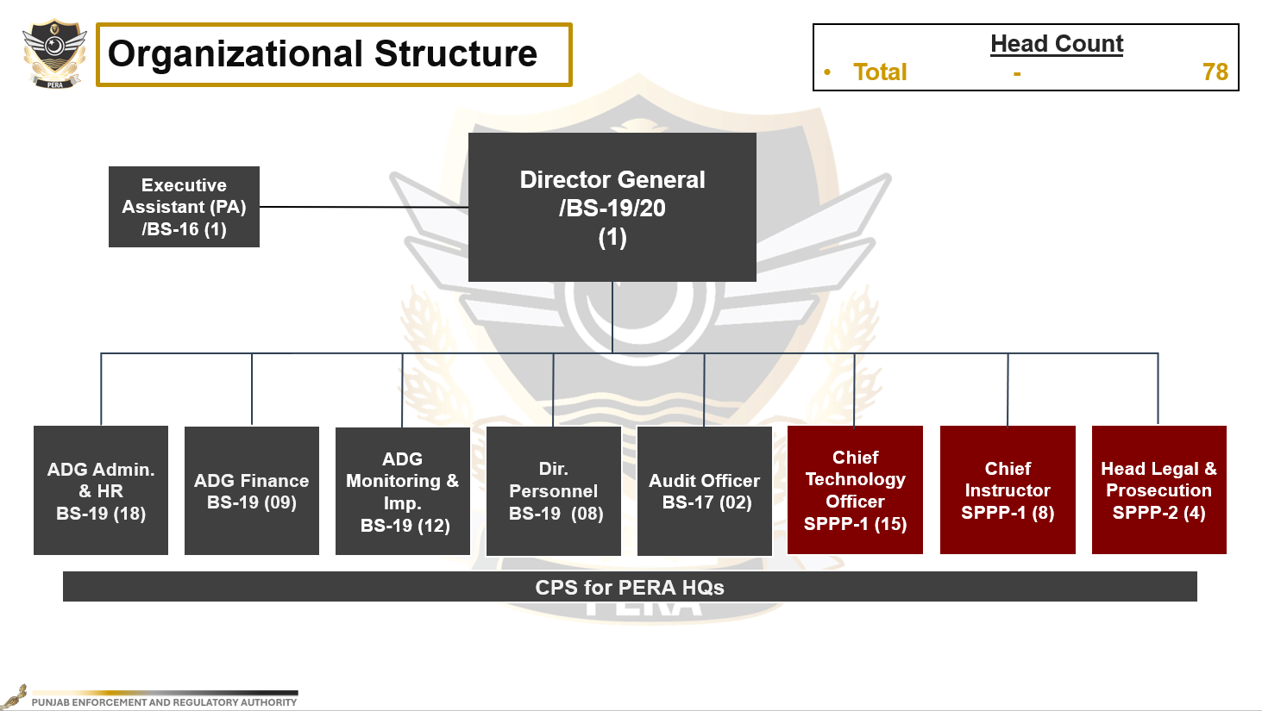
ORGANIZATIONAL STRUCTURE
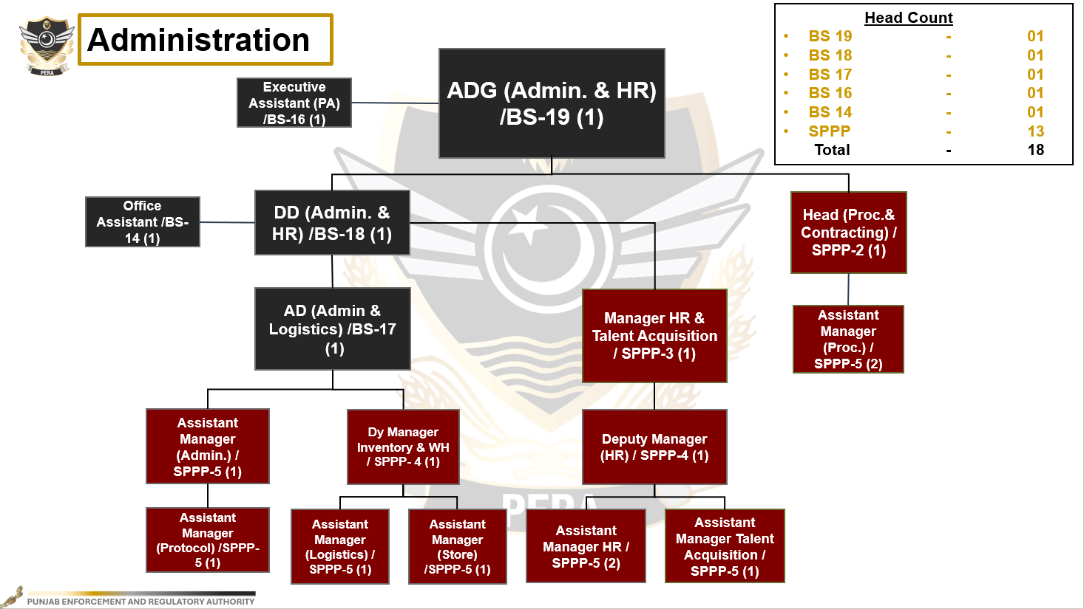

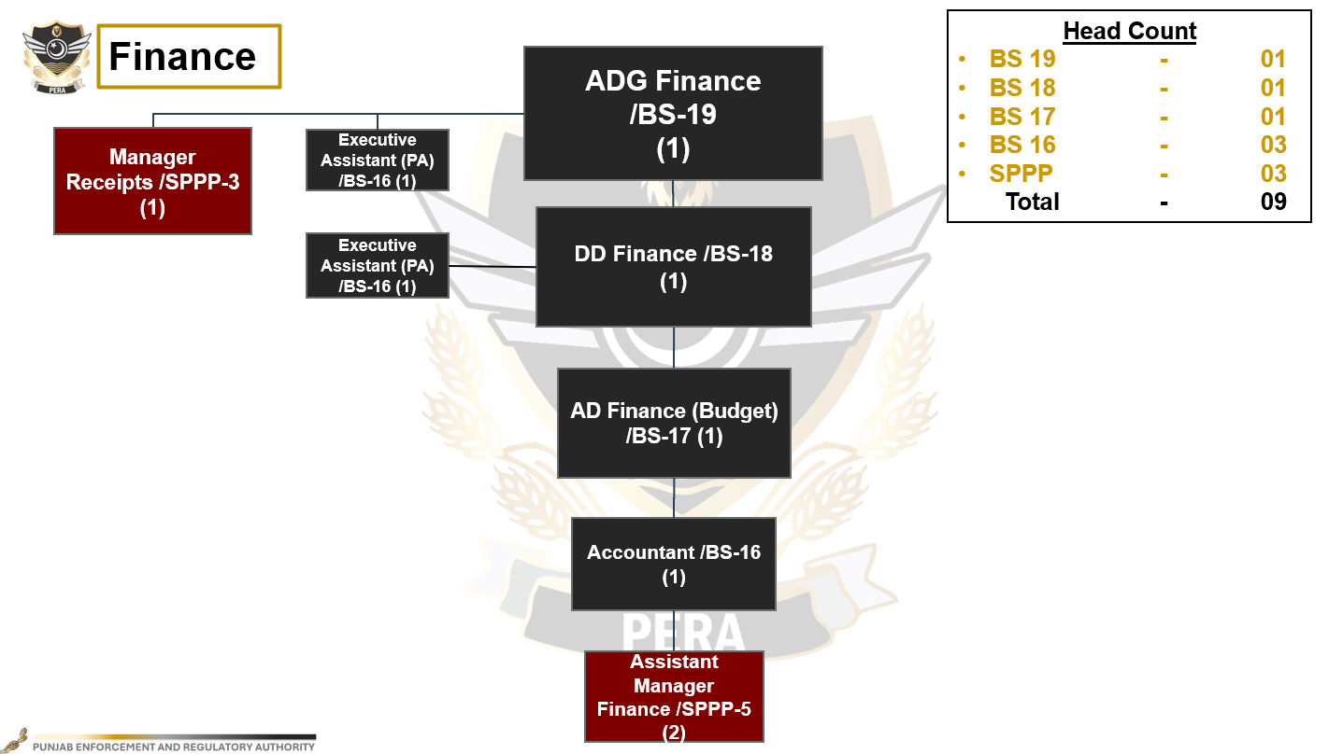

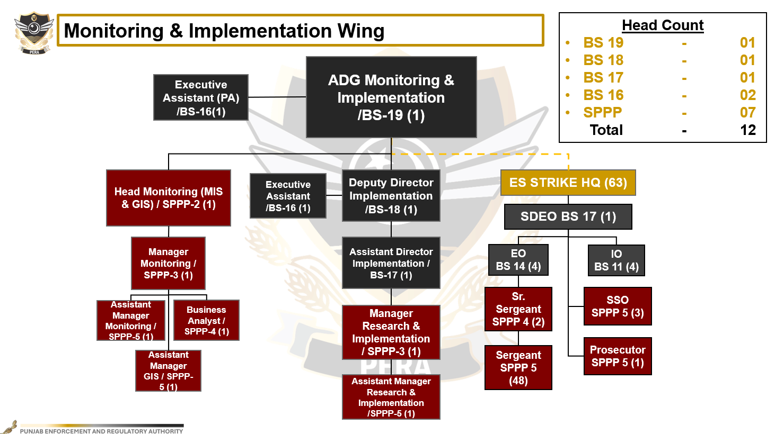

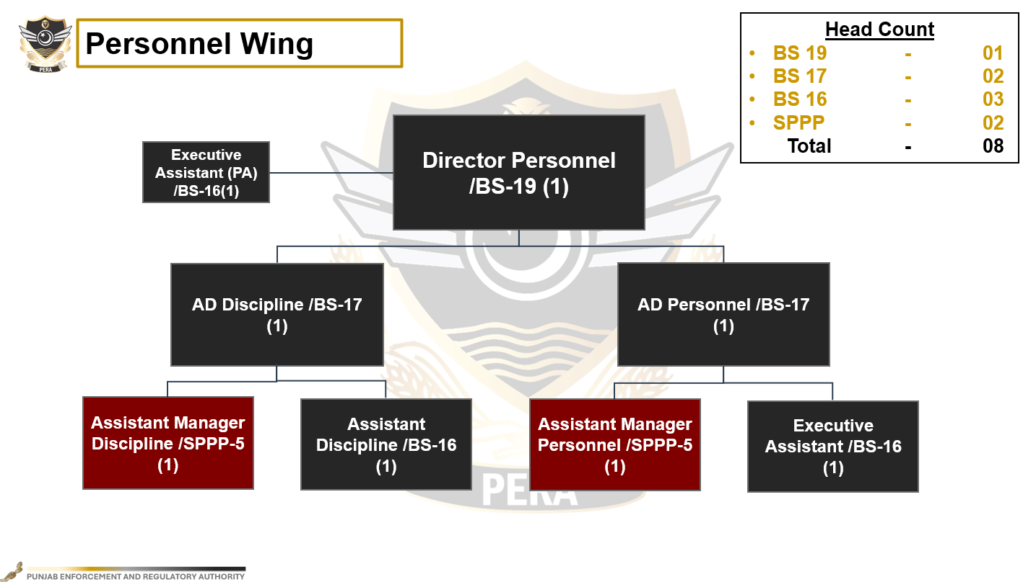

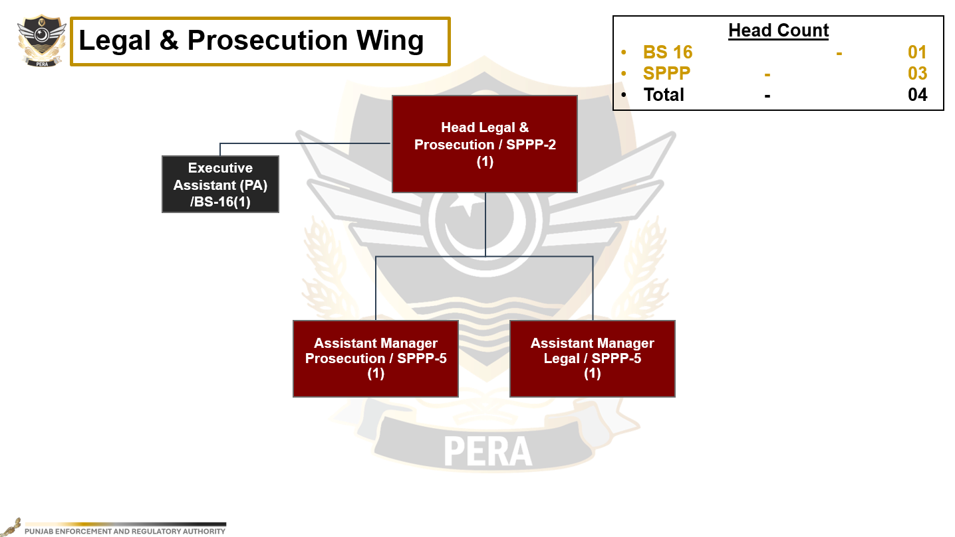

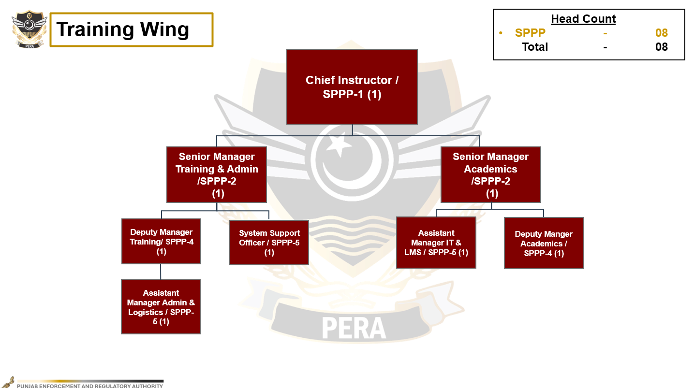

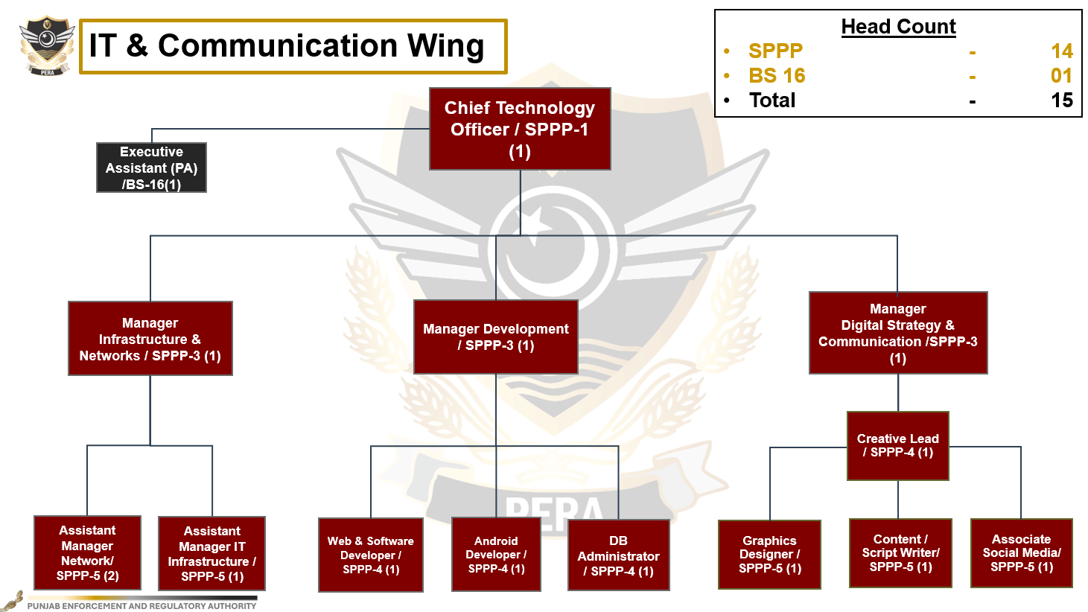

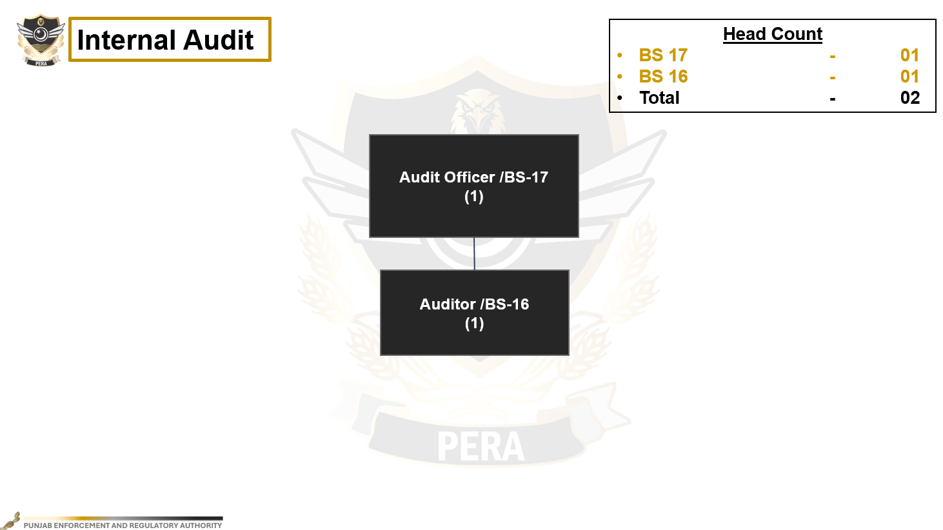

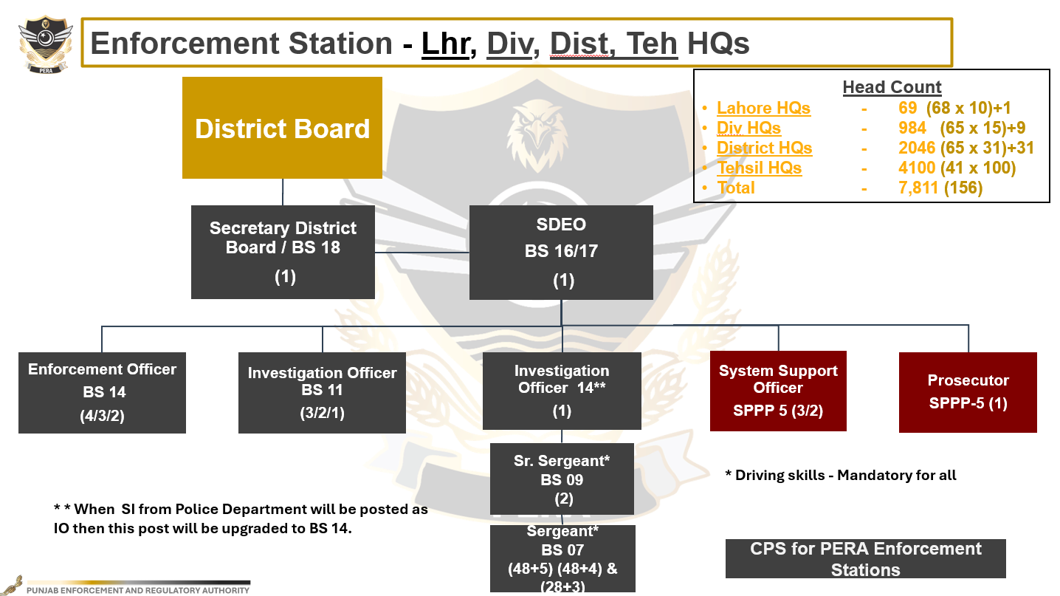
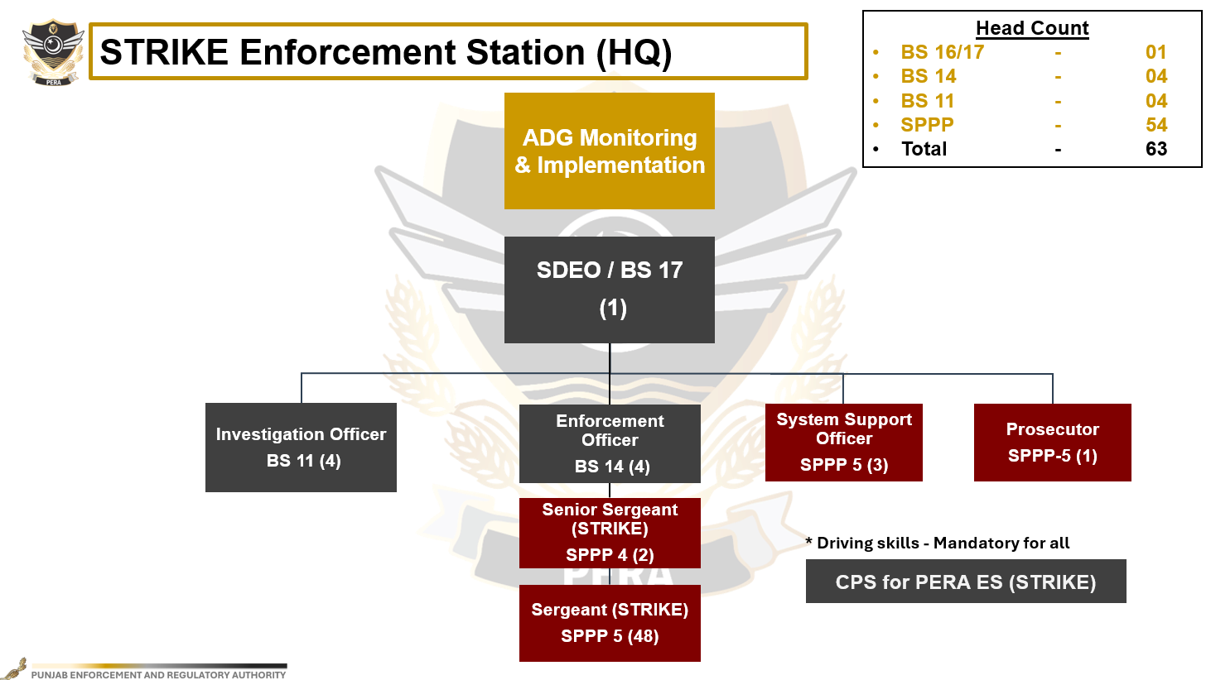

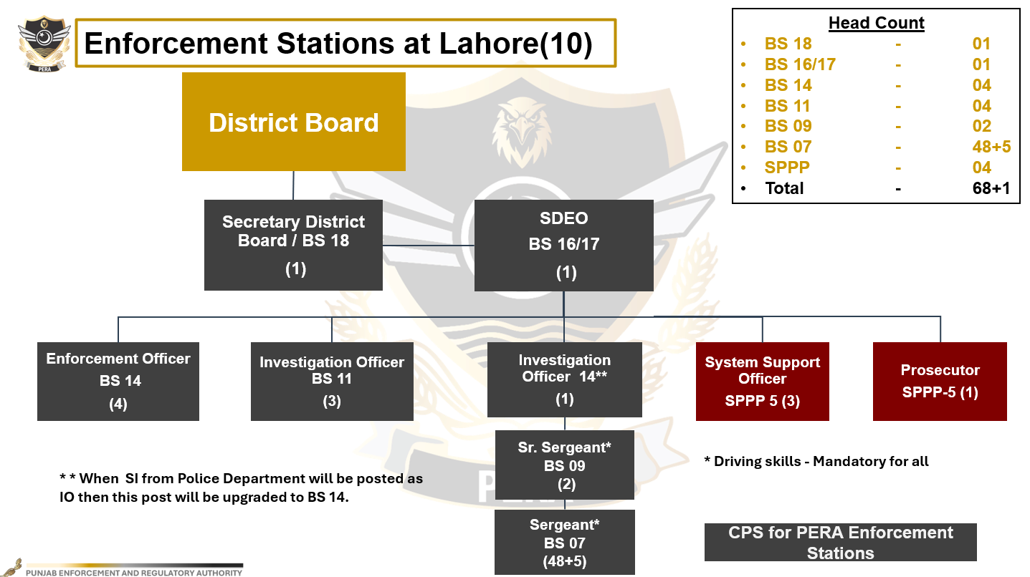
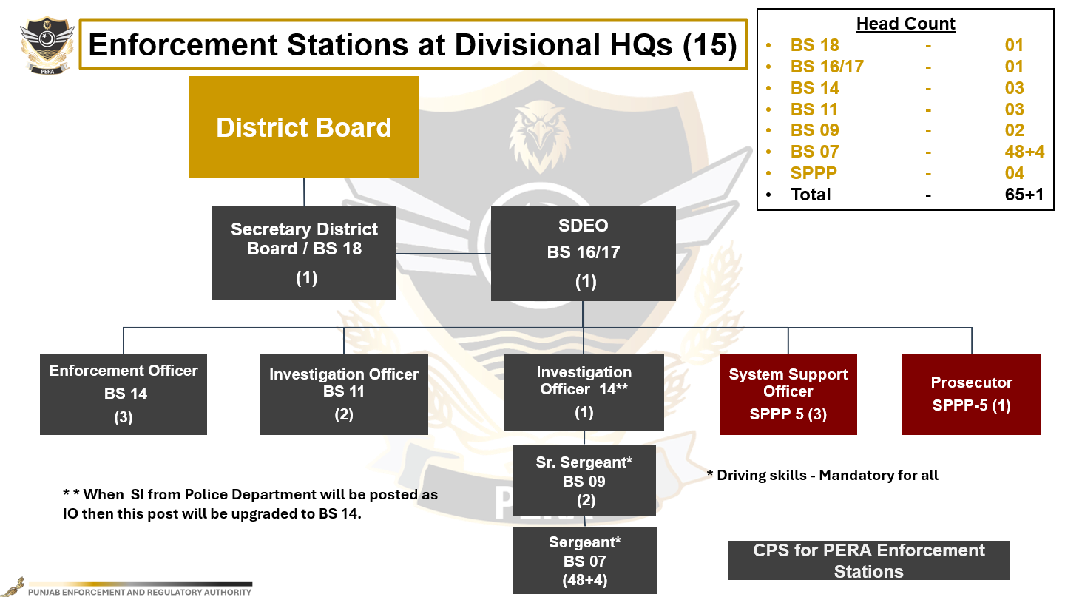

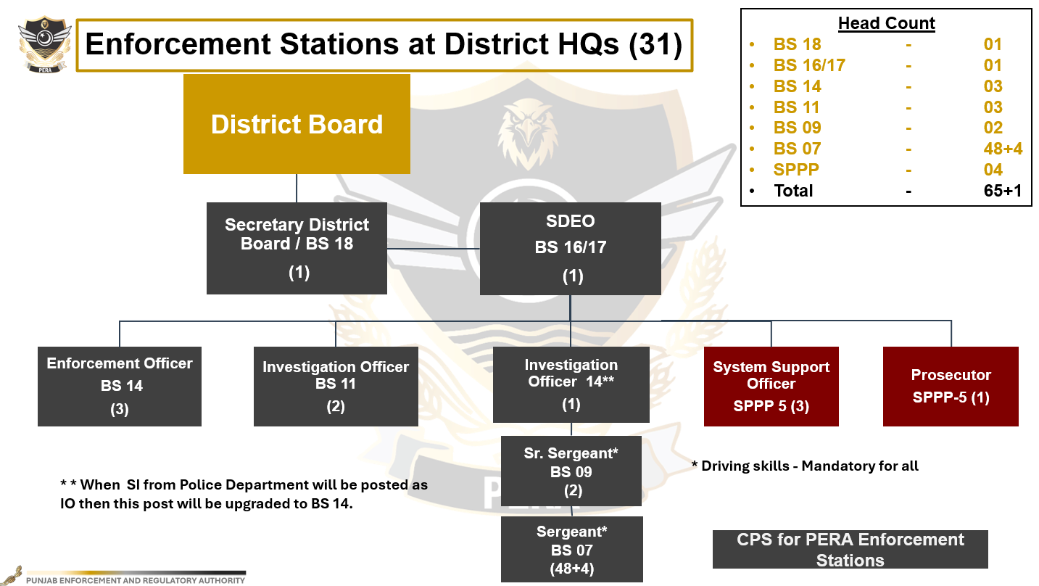

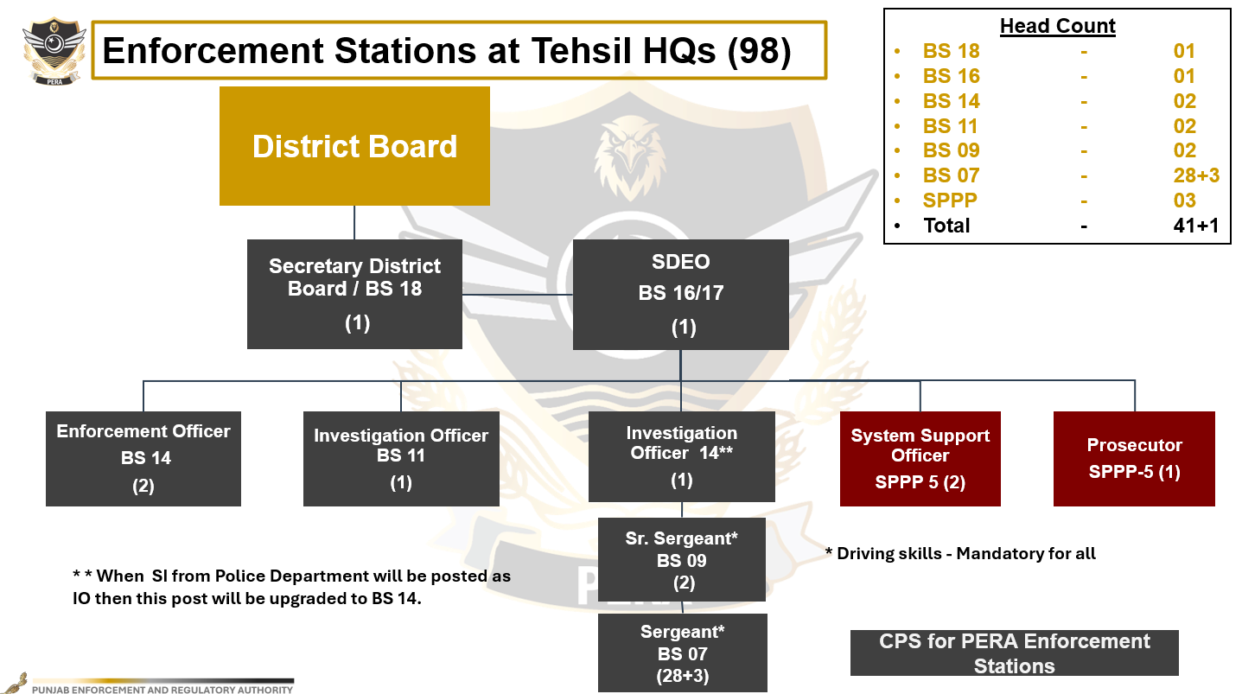

Schedule-II
Conditions of Service

Directorate General

Sr. No. | Name of Post with BS | Appointing Authority | Minimum Qualification for Appointment / Promotion | Method of Appointment | Age for  Initial  Recruitment
 |  |  |  |  | Min | Max
1 | 2 | 3 | 4 | 5 | 6 | 7
1 | Director  General  (BS-20) | Chief Minister | - | By Transfer from amongst the Officers belonging to Pakistan Administrative Service or Provincial Management Service of BS-20. | - | -
2 | Additional Director General  (BS-19), other than Additional Director General (Monitoring & Implementation) | Chief Secretary | - | By Transfer from amongst the Officers belonging to Pakistan Administrative Service or Provincial Management Service of BS-19;  Or  By Deputation - An Officer of BS-19 of any other service who meets the Terms of Reference for Service. | - | -
3 | Additional Director General (Monitoring & Implementation) (BS-19) | Chief Secretary | By promotion from amongst the Secretaries, District Enforcement & Regulatory Boards (BS-18)  - Minimum 7 years of service in BS-18  - Should have cleared necessary training as prescribed  - Fitness Certificate from Medical Board | If none is available by promotion, then by Transfer from amongst the Officers belonging to Pakistan Administrative Service or Provincial Management Service of BS-19;  Or  By Deputation - An Officer of BS-19 of any other service who meets the Terms of Reference for Service. | - | -
4 | Director  Personnel  (BS-19) | Chief Secretary | - | By Deputation - An Officer of BS-19 belonging to Police Service of Pakistan or of any other service who meets the Terms of Reference for Service. | - | -
5 | Deputy Director  (BS-18) | Chief Secretary | - | By Transfer from amongst the Officers belonging to the Pakistan Administrative Service or Provincial Management Service of BS-18;  Or  By Deputation - An Officer of BS-18 of any other service who meets the Terms of Reference for Service. | - | -
6 | Assistant Director  (BS-17) other than AD Personnel & AD Discipline | Chief Secretary | - | By Transfer from amongst the Officers belonging to Pakistan Administrative Service or Provincial Management Service of BS-17;  Or  By Deputation - An Officer of BS-17 of any other service who meets the Terms of Reference for Service. | - | -
7 | Assistant Director (Personnel)  (BS-17) | Chief Secretary | - | By Deputation - An Officer belonging to Police Service of Pakistan of BS-17 or of any other service who meets the Terms of Reference for Service. | - | -
8 | Assistant Director (Discipline)  (BS-17) | Chief Secretary | - | By Deputation - An Officer belonging to Police Service of Pakistan of BS-17 or of any other service who meets the Terms of Reference for Service. | - | -
9 | Audit Officer  (BS-17) | Chief Secretary | - | By Deputation - An Officer of the Local Fund Audit Department of Government of the Punjab of BS-17;  Or  An Officer of BS-17 of any other service who meets the Terms of Reference for Service. | - | -
10 | Auditor  (BS-16) | Chief Secretary | - | By Deputation - An Officer of the Local Fund Audit Department of Government of the Punjab of BS-16;  Or  An Officer of BS-16 of any other service who meets the Terms of Reference for Service. | - | -
11 | Executive Assistant  (BS-16) | Director General | At least BA / BBA or equivalent degree from a recognized University;  All Executive Assistants may be posted within the Directorate General by the DG as PAs, MTO, Caretakers, Accountants, as per administrative requirements. | By initial recruitment;  Or  By Deputation - An Officer of BS-16 of any other service who meets the Terms of Reference for Service. | 22 | 30
12 | Office Assistant  (BS-14) | Director General | At least BA / BBA or equivalent degree from a recognized University. | By initial recruitment;  Or  By Deputation - An Official of BS-14 of any other service who meets the Terms of Reference for Service | 22 | 30

Enforcement Stations

Sr. No. | Name of Post with BS | Appointing Authority | Minimum Qualification for Appointment / Promotion | Method of Appointment | Age for  Initial  Recruitment
 |  |  |  |  | Min | Max
1 | 2 | 3 | 4 | 5 | 6 | 7
13 | Secretary, District Enforcement & Regulatory Board  (BS-18) | Chief Secretary | - Minimum 7 years of service in BS-17  - Should have cleared necessary training as prescribed  - Fitness report by Medical Board | 100% by promotion on the basis of seniority-cum-fitness from amongst the Sub Divisional Enforcement Officers of BS-17.  Or  If none is available by promotion, then by Deputation from amongst the Officers of Pakistan Administrative Service or Provincial Management Service of BS-18. | - | -
14 | Sub Divisional Enforcement Officer  (BS-17) | Director General | - Minimum 5 years of service in BS-16  - Should have cleared necessary training as prescribed  - Fitness report by Medical Board | 100% by promotion on the basis of seniority cum fitness from amongst the Sub Divisional Enforcement Officers of BS-16;  Or  If none is available by promotion, then by Deputation from amongst the Officers of Pakistan Administrative Service or Provincial Management Service of BS-17. | - | -
15 | Sub Divisional Enforcement Officer  (BS-16) | Director General | - For Initial Appointment  Bachelor (Honors) or Equivalent from a recognized University  - For Promotion  - Minimum 5 years of service in BS-14  - Should have cleared necessary training as prescribed  - Fitness certificate from Medical Board | - 70 % by initial recruitment;  - 30 % by promotion from amongst the Enforcement Officers (BS-14) on seniority-cum-fitness basis;  Or  By Deputation - An Officer of BS-16 from any other service who meets the Terms of Reference of Service.  among the officer of Revenue Service (Tehsildar) who has been appointed through Punjab Public Service Commission | 22 | 35
16 | Enforcement Officer  (BS-14) | Director General | - For Initial Appointment  Bachelor (Honors) or Equivalent from a recognized University  - For Promotion  - Minimum 5 years of service in BS-11  - Should have cleared necessary training as prescribed  - Fitness report by Medical Board | - 80 % by Initial recruitment;  - 20 % by promotion from amongst the Investigation Officers (BS-11) on seniority-cum-fitness basis. | 22 | 32
17 | Investigation Officer  (BS-11) | Director General | - For Appointment  Bachelor (Honors) or Equivalent from a recognized university  - For Promotion  - Minimum 5 years of service in BS-09 or BS-07  - Should have cleared necessary training and departmental examination, as prescribed  - Fitness report by Medical Board | - 70 % by Initial recruitment;  - 10 % by promotion from amongst the Senior Sergeants (BS-09) on seniority-cum-fitness basis;  - 20 % by direct promotion from amongst the Sergeants (BS-07) on performance and seniority-cum-fitness basis. | 22 | 28
18 | Senior Sergeant  (BS-09) | Director General | - Minimum 5 years of service in BS-07  - Should have cleared necessary training and departmental examination, as prescribed  - Fitness report by Medical Board | 100% by promotion on the basis of seniority-cum-fitness from amongst the Sergeants (BS-07);  OR  If none is available, then by Deputation from any other Law Enforcement Agency who meets the Terms of Reference for Service. | - | -
19 | Sergeant  (BS-07) | Director General | Intermediate from a recognized Board of Intermediate and Secondary Education | - 100% by Initial Recruitment;  Or  - By Deputation from any other Law Enforcement Agency who meets the Terms of Reference for Service.  - In case of deputation, the Deputationist must be freshly recruited, as prescribed by the Authority, but must not be a probationer. | 18 | 26

Schedule-III
Terms and Reference for Service

Position Title: Director General PERA

Reports To: Authority

Purpose of the Position:

He will be responsible for assisting the Authority in performing its functions and exercising its powers as mentioned in the Act. He will carry out overall supervision of operations of HQ and Enforcement Stations on behalf of the Authority. He will be responsible for providing all kinds of operational support to the Authority. He will perform the duties as assigned or delegated to him by the Authority and will monitor the implementation of directions of the Authority and the scheduled laws across the province.

Areas of Responsibilities:

- He will monitor the implementation of decisions of the Authority.
- He will monitor the implementation of scheduled laws under the Act.
- He will assist the Authority in framing rules, regulations and policy guidelines related to the operation of the Authority as well as for implementation of scheduled laws under the act.
- He will provide secretariat support to the independent members under
- He will ensure the maintenance of a complete record of the meetings of the Authority along with the details of proceedings and decisions.
- He will assist the authority in the establishment of a functional organization under the Act.
- Have the powers equal to Secretary of a Department / organization.
- He will assist the Authority in hiring of employees and procurement of logistics for establishment of Head Quarter and Enforcement Stations.
- He will assist the authority in dealing with all of the financial matters of the Authority including management of the Fund.
- He will be responsible for overseeing day-to-day operations of the Authority under the powers delegated to him.
- Will be responsible for assisting the Authority in carrying out the purposes of the Act and implementing the vision of the Authority.
- He will be responsible for assisting the Authority in carrying out all of its functions and exercising all of its powers.
- He will provide decision support to the authority.
- Any other functions and powers delegated or assigned to him by the Authority.

Competencies & Personal Attributes:

- Leadership skills
- Strategic thinking
- Communication Skills
- Team management skills
- Analytical skills
- Presentation skills
- Should possess understanding of scheduled laws of PERA
- Must be proficient in the use of IT
- Negotiation skills and resilience

Appointment:

As explained in column 5 of Schedule-II.

Salary and Benefits:

Pay & Allowances equivalent to BS-20 + PERA Special Allowance + Vehicle + any other benefits admissible to this position.
Position Title: Additional Director General (Administration & HR)

Reports To: Director General

Purpose of the Position:
He is responsible for managing all the activities of Administration, HR, Procurement & Logistics as per the desired standards, policies, rules & regulations. He shall assist the Director General in management and service delivery regarding administration, facilities, procurement, logistics and human resource management.

Areas of Responsibilities:
Administration related Responsibilities:
- Will oversee and supervise matters related to performance appraisal system of employees, pay plan, benefits program, training needs and orientation sessions etc.
- To report to management and provide decision support through HR metrics.
- Assist the working of relevant recruitment/ selection committees.
- Development and monitoring of HRMIS in coordination with IT & Communications Wing related to HQ and Enforcement Stations.
- Overall monitoring and supervision of recruitment / hiring / transfer / posting of establishment of PERA in accordance with the service regulations.
- Ensure complete record keeping of all employees of PERA.
- Development, monitoring and implementation of hiring regulations and terms and condition of services for the employees.
Procurement & Logistics related Responsibilities:
- Ensure execution of procurement plans, request for proposals (RFPs) / Terms of Reference (TORs) in accordance with the Punjab Procurement Rules, 2014.
- Supervision of bidding process and RFPs by reviewing specifications and scheduling.
- Overall supervision of procurement process and coordination with the relevant Wings at HQ and the Enforcement Stations.
- Monitor the development of specific contract agreements, purchase orders, frameworks agreements and SLAs etc.
- Reviewing price analytics & evaluation matrices.
- Design and implement procurement monitoring plans to ensure timelines.
- Supervision of stocks, inventories, office supplies, vehicles, equipment, uniform, fuel etc. for HQ and Enforcement Stations.
- Responsible for repair and maintenance of office equipment and equipment for enforcement across the Enforcement Stations.
- Maintenance of office building at Headquarter and buildings of Enforcement Stations.
Competencies & Personal Attributes:
- Leadership / Management skills.
- Relationship Management & Communication Skills.
- Analytical skills, presentation skills and report writing.
- Sound understanding of management and administration procedures.
- Proper understanding of Rules of Business, Contract Appointment Policy, Recruitment Policy, Deputation Policy, Punjab Procurement Rules, 2014, Conduct Rules, etc.
- Should have proficiency in the use of IT

Appointment:

As explained in column 5 of Schedule-II.

Salary and Benefits:
Pay & Allowances equivalent to BS-19 + PERA Special Allowance or Deputation Allowance + Vehicle + any other benefits admissible to this position.

Position Title: Additional Director General (Finance)

Reports To: Director General

Purpose of the Position:

He is responsible for managing all the activities related to financial management as per the desired standards of governance in accordance with policies, rules & regulations. The person assists the Director General in management of Budget, Forecasting, Risk Management and the internal control system.

Areas of Responsibilities:
- Ensure financial prudence / propriety through impartiality, openness and competitive environment.
- Closely Monitor flow of expenditure as per prevailing law / rules / regulations / policies.
- Manage updating of files / records for proper conduct of Audit in a transparent manner.
- Assist DG in formulation of Budget proposals and Schedule of New Expenditure proposals.
- Recommend priorities to the DG in allocation of funds.
- Allocate Head, sub-head wise budget for smooth and transparent financial management.
- Supervise matters related to salaries/payroll of staff at Headquarter and Enforcement Stations.
- Supervision of Authority’s Accounts.
- Supervision of the process of development and updating of financial regulations of PERA.
- All kinds of financial reporting.
- Overall supervision, monitoring and operation of financial matters of PERA.
- Submission of Annual Performance Report to the Authority for further submission to the Government.
- Exercise powers delegated by the Competent Authority.
- Supervision related to the Budget and its utilization at Enforcement Stations.
- Responsible for maintenance of Authority’s fund.
- Any other task assigned by the DG in line with the Act, rules and regulations.

Competencies & Personal Attributes:

- Leadership/ Management skills.
- Relationship management & Communication Skills.
- Analytical skills
- Presentation skills and report writing.
- Sound understanding of Financial Management and procedures.
- An understanding of Rules of Business, Contract appointment policy, Recruitment policy, Deputation Policy, PPRA rules, Conduct rules, etc.
- Should have proficiency in the use of IT

Appointment:

As explained in column 5 of Schedule-II.

Salary and Benefits:

Pay & Allowances equivalent to BS-19 + PERA Special Allowance or Deputation Allowance + Vehicle + any other benefit admissible to this position.

Position Title: Director (Personnel)

Reports To: Director General

Purpose of the Position:

He is responsible for coordination with the Enforcement Stations regarding efficient and effective administration of the enforcement personnel deployed at the ESs in order to fulfil the desired standards in accordance with law, policies, rules & regulations. He will also carry out necessary liaison with other Law Enforcement Agencies for requisitioning services of suitable staff and clearance from Deputationist Screening Panels apart from looking after discipline of the deputation staff.

Areas of Responsibilities:
- Supervise the deputation, posting, and transfer of Investigating Officers, Senior Sergeants, and Sergeants across all Enforcement Stations.
- Control and supervision over disciplinary matters concerning the aforementioned deputation staff and to ensure adherence to the Authority’s code of conduct and behavioral protocols.
- Monitoring the performance of field staff, preparing reports, and recommending disciplinary actions where required.
- Oversee capacity-building initiatives, including nominations for training, workshops, and professional development programs.
- Development of deployment strategies for enforcement operations, compliance monitoring, and other field tasks.
- Timely resolution of service matters and welfare concerns of deputation staff.
- Maintaining an updated database of the deputation staff.
- Maintaining close coordination with other LEAs.

Competencies & Personal Attributes:

- Leadership/ Management skills.
- Communication Skills.
- Analytical skills.
- Presentation skills.
- Thorough knowledge of Deputation Policy
- Should be proficient in the use of IT.
- Should possess sufficient understanding of scheduled laws of PERA
- Knowledge about E&D Rules of Punjab Police as well as of Service Regulations of PERA

Appointment:

As explained in column 5 of Schedule-II.

Salary and Benefits:

Pay & Allowances equivalent to BS-19 + PERA Special Allowance or Deputation Allowance + Vehicle + any other benefit admissible to this position.

Position Title: Additional Director General (Monitoring & Implementation)

Reports To: Director General

Purpose of the Position:

He shall be responsible for coordination with District Enforcement and Regulatory Boards and Enforcement Stations, across Punjab in order to monitor implementation of standardized procedures laid down by the Authority. He shall assist the Director General in preparation of SOPs, Guidelines, Advisories and Notifications related to operations and procedures to be followed at the Enforcement Stations and by the DERBs. He shall also assist the Director General in effective decision making keeping in view the data analytics related to functioning of the Enforcement Stations and the DERBs.

Areas of Responsibilities:
- Design, develop, and implement monitoring frameworks, KPIs, and evaluation methodologies.
- Oversee real-time and periodic monitoring of field operations, regulatory enforcement activities, and special campaigns.
- Establish and manage mechanisms for operational data collection, verification, and analysis.
- Supervise the implementation of approved SOPs, policies, and strategies in the field.
- Ensure that enforcement and regulatory operations align with legal mandate, government policies, and international best practices.
- Identify gaps or bottlenecks in implementation and recommend corrective actions to the Director General.
- Prepare comprehensive operational and performance reports for submission to the Director General and the Authority.
- Ensure timely and accurate documentation of enforcement activities and compliance metrics.
- Develop protocols for operational audits and quality assurance reviews.
- Collaborate with Legal & Prosecution, Admin. & HR, IT & Communication, Personnel, Finance Wings at PERA HQ to ensure cross-functional support for achievement of implementation objectives.
- Coordinate with external stakeholders including government departments, civil society organizations, and oversight bodies.
- Lead the development and delivery of training programs for monitoring staff based on best practices in compliance and performance measurement.
Competencies & Personal Attributes:

- Leadership / Management skills.
- Communication skills.
- Analytical skills.
- Presentation skills.
- Thorough knowledge PERA’s business
- Should be proficient in the use of IT.
- Should possess sufficient understanding of scheduled laws of PERA

Appointment:

As explained in column 5 of Schedule-II.

Salary and Benefits:

Pay & Allowances equivalent to BS-19 + PERA Special Allowance or Deputation Allowance + Vehicle + any other benefit admissible to this position.

Position Title: Deputy Director (Administration & HR)

Reports To: Additional Director General (Administration & HR)

Purpose of the Position:

To assist Additional Director General (Administration & HR) in carrying out Human Resource Management at Head Quarter and Enforcement Stations of PERA and managing activities such as recruitment, employee relations, performance management, training & development etc.

Areas of Responsibilities:

- Responsible for carrying out the recruitment and selection process as prescribed.
- Managing the employee life cycle (i.e., recruiting, hiring, on boarding, training, transfer/posting, leave and administering employee benefits).
- Will develop performance appraisal/management system for employees of PERA.
- Will develop pay plan and benefits program.
- Will be responsible for developing and implementation of code of conduct for staff at Headquarter and Enforcement Stations.
- Will develop and ensure implementation of attendance management system and HRMIS
- Will assist Director Admin and Finance in Appointment, Transfer/posting and service matters of employees at Head Quarter and Enforcement Stations of PERA.
- Will be responsible for development of training programs for employees.
- Will perform all functions related to Human Resource Management in the Organization.
- Any other task assigned by the Competent Authority.

Competencies & Personal Attributes:

- Leadership/ Management skills.
- Relationship management & Communication Skills.
- Analytical skills
- Presentation skills and report writing.
- An understanding of Rules of Business, Contract appointment policy, Recruitment policy, Deputation Policy, PPRA rules, Conduct rules, etc.
- Should have proficiency in the use of IT
- Integrity and Empathy
- Conflict resolution skills

Appointment:

As explained in column 5 of Schedule-II.

Salary and Benefits:

Pay & Allowances equivalent to BPS-18 + PERA Special Allowance or Deputation Allowance + Vehicle + any other benefit admissible to this position.

Position Title: Deputy Director (Finance)

Reports to: Additional Director General Finance

Purpose of the Position:

To assist Additional Director General (Finance) in carrying out all functions related to financial management, planning, budgeting and accounts of PERA at Headquarter as well as at Enforcement Stations.

Areas of Responsibilities:

- Deal with all of the matters related to salaries of PERA’s employees
- Responsible for timely processing of payroll of PERA employees.
- Supervise book keeping and ensure maintenance of proper book of accounts including booking of expenditures related to operational activities at Enforcements Stations.
- Reconciliation of expenditures with AG Office, treasury office and with all bank accounts.
- Guide Enforcement stations staff for operational expenditures.
- Monitor advances and their timely clearance.
- Responsible for all tax related matters of PERA and its Enforcement Stations.
- Supervise monthly, half yearly and annual financial statement of PERA
- Budgeting and forecasting
- Present monthly financial reporting of PERA to management.
- Responsible for processing of funds requirement cases for Enforcement Stations on the basis of Financial reports of Enforcement Stations.
- Monitor bank accounts of Enforcement Stations.
- Responsible for application of correct withholding rates on vendor payments.
- Responsible for updating of payroll register regarding terminations, transfers, leave deductions and resignations, etc.
- Liaison with banks for transfer of salaries into employee’s accounts.
- Resolve & guide employees on payroll issues.
- Issue monthly pay slips to all employees.
- Responsible for reconciliation of accounts of PERA.
- Any other task assigned by the Competent Authority.

Competencies & Personal Attributes:

- Relationship management & Communication Skills.
- Interpersonal skills.
- Analytical skills.
- Presentation skills.
- Should be proficient in the use of IT
- Understanding of Financial Rules of Government of Punjab and PERA’s financial regulations
- Risk management skills
- Financial reporting skills

Appointment:

As explained in column 5 of Schedule-II.

Salary and Benefits:

Pay & Allowances equivalent to BPS-18 + PERA Special Allowance or Deputation Allowance + Vehicle + any other benefit admissible to this position.

Position Title: Deputy Director (Implementation)
Reports to: Additional Director General (Monitoring & Implementation)

Purpose of the Position:

The Deputy Director (Implementation) shall be responsible for ensuring the effective enforcement of PERA’s mandate across the province, maintaining operational transparency, and overseeing all field activities of the Enforcement Squad. The incumbent will coordinate the implementation of directives issued by the Authority, supervise recruitment, postings, transfers, contract renewals, terminations, performance appraisals, and disciplinary actions related to Enforcement Officers, System Support Officers, and Investigation Officers. All intelligence and inspection reports concerning enforcement operations shall be routed through the Deputy Director to ensure integrity, accountability, and uniform application of PERA’s enforcement standards.

Areas of Responsibilities:

- Execute and supervise enforcement activities as per PERA’s mandate and directives issued by the Director General.
- Ensure uniform compliance with enforcement procedures, field inspection protocols, and transparency mechanisms.
- Monitor and evaluate implementation progress, identifying operational bottlenecks and proposing corrective measures.
- Oversee recruitment processes for Enforcement Station staff, ensuring merit, transparency, and adherence to PERA’s recruitment policy.
- Administer contract renewals, extensions, postings, and transfers of System Support Officers in coordination with the Admin & HR Wing.
- Recommend disciplinary action, termination, or contract non-renewal in cases of misconduct, negligence, or poor performance.
- Supervise and review annual performance appraisals of enforcement staff, ensuring objective evaluation and linkage with renewal, promotion, or disciplinary decisions.
- Maintain performance dashboards and records for all field officers to enable data-driven accountability.
- Receive, analyse, and consolidate all intelligence reports from the Enforcement and Investigation units.
- Initiate inquiries or fact-finding proceedings against officers under suspicion of corruption, malpractice, or dereliction of duty.
- Ensure all intelligence inputs are confidentially handled and submitted to the ADG for final review and action.
- Develop intelligence-gathering mechanisms to pre-empt violations of PERA’s regulatory framework.
- Maintain a transparent record of enforcement actions, officer conduct, and administrative decisions.
- Submit periodic performance and intelligence summaries to the Director and recommend policy-level improvements for systemic efficiency.
- Serve as the focal officer for field data validation and verification of enforcement outcomes.
- Exercise direct administrative and functional control over the Intelligence Wing to ensure effective collection, collation, and analysis of field intelligence related to enforcement, compliance, and emerging regulatory risks.
- Oversee systematic intelligence gathering from Enforcement Stations and external sources, ensuring verification and classification of actionable information.
- Maintain close coordination with Chairperson/ Secretary DERB, field units, and relevant enforcement or security agencies for intelligence sharing, joint operations, and preventive interventions.
- Prepare and submit confidential intelligence briefs, risk assessments, and analytical reports to the Director (Implementation) and Director General for policy and operational decision-making.
- Ensure strict confidentiality, secure record-keeping, and controlled dissemination of intelligence data in accordance with official secrecy and regulatory protocols.

Competencies & Personal Attributes:
- Relationship management & Communication Skills.
- Analytical skills.
- Should be proficient in the use of IT
- Understanding of Financial Rules of Government of Punjab and PERA’s financial regulations
- Risk management skills
- Financial reporting skills

Appointment:

As explained in column 5 of Schedule-II.

Salary and Benefits:

Pay & Allowances equivalent to BPS-18 + PERA Special Allowance or Deputation Allowance + Vehicle + any other benefit admissible to this position.

Position Title: - Assistant Director (Administration & Logistics)
Reports To: Deputy Director (Administration & HR)

Purpose of the Position:

To assist the Deputy Director (Administration & Logistics) in organizing, coordinating, and managing PERA’s employees to carry out its vision and goals through recruiting, hiring, and capacity building programs.

Areas of Responsibilities:

- Maintain pay plan and benefits program.
- Monitor attendance management system and put up daily and monthly attendance reports.
- Will assess training needs to apply and monitor training & capacity building program
- Will supervise pay plan and benefits program.
- Ensure legal compliance throughout the Human Recourse Management.
- Will be responsible to report to management and provide decision support.
- Will be responsible for hiring on the positions of SDEOs (BS-16), Enforcement officers (BS-14), IOs (BS-11) and Resident Engineers and other arrangement required for it.
- Will be responsible for hiring of Prosecutors (BS-17) at Enforcement Stations.
- Any other task assigned by the Competent Authority.
- Ensures efficient coordination of various cost centres (at Headquarter and Enforcement stations) departmental grant, and designated accounts by implementing budgeting system and financial records as per rules.
- Furnish advice to the DD Finance regarding financial decisions by providing accurate information on the financial status of all accounts and s cost centre as a whole.
- Responsible for all tax related matters of PERA and its Enforcement Stations.
- Assists the Deputy Director Finance in annual budgeting and financial planning by providing allocation and expense projections.
- To ensure the financial integrity of departmental, grant, and designated budgets by monitoring balances and expenditures
- Provides assistance to the Deputy Director Finance by collecting, organizing, and analysing financial and other statistical data for the preparation of financial and non-financial reports, establishing reporting deadlines for cost centre staff providing data for these reports.
- Supervise monthly, half yearly and annual financial statement of PERA
- Present monthly financial reporting of PERA to management.
- To create liaison between the cost centre and Financial Services on financial matters such as budget submission and clarification of financial and budgetary policies and procedures, particularly relating to grants and contracts compliance.
- To assist the cost centre head and AD logistics by coordinating the purchase of supplies and equipment by identifying prospective vendors, obtaining cost estimates, selecting equipment and related vendors, serving as a liaison between the cost centre and various departments, and overseeing the purchasing process.
- Any other task assigned by the Competent Authority.

Competencies & Personal Attributes:

- Leadership/ Management skills.
- Relationship management & Communication Skills.
- Analytical skills
- Presentation skills and report writing.
- An understanding of Rules of Business, Contract appointment policy, Recruitment policy, Deputation Policy, PPRA rules, Conduct rules, etc.
- Should have proficiency in the use of IT
- Integrity and Empathy
- Conflict Management skills

Appointment:

As explained in column 5 of Schedule-II.

Salary and Benefits:

Pay & Allowances equivalent to BPS-17 + PERA Special Allowance or Deputation Allowance + Vehicle + any other benefit admissible to this position.

Position Title: - Assistant Director (Implementation)
Reports To: Deputy Director (Implementation)

Purpose of the Position:

The Assistant Director (Implementation) shall support the Deputy Director (Implementation) in supervising enforcement operations, ensuring uniform implementation of procedures, coordinating intelligence inputs, and assisting in the monitoring and evaluation of field and system-based enforcement activities. The position shall also oversee research, system implementation, regulatory compliance reviews, and inter-departmental coordination to support evidence-based decision-making and operational efficiency.

Areas of Responsibilities:

- The Assistant Director (Implementation) shall assist the Deputy Director in executing and supervising enforcement activities as per PERA’s mandate and directives issued by the competent authority.
- Ensure that enforcement staff uniformly follow approved procedures, field inspection protocols, reporting formats, and transparency mechanisms.
- Regular implementation reviews to identify operational gaps, compliance deficiencies, and procedural deviations, and shall propose corrective and preventive measures.
- Support field data validation and verification processes to ensure accuracy, transparency, and evidence-based reporting of enforcement outcomes.
- The Assistant Director shall oversee regulatory research functions in coordination with the Manager (Research & Implementation), ensuring that all implementation processes remain aligned with applicable laws, rules and regulatory requirements.
- Collaborate with the IT Wing and R&I Wing to support the design, testing, validation, and deployment of system-based enforcement tools, digital inspection modules, and reporting mechanisms.
- Assist in the preparation of project plans, timelines, and resource allocation frameworks for implementation initiatives.
- Regularly monitor progress on system implementation tasks, identify risks, and recommend mitigation strategies to the Deputy Director (Implementation).
- Ensure timely communication with internal and external stakeholders for requirement gathering, project scope definition, and refinement of digital enforcement solutions.
- Assist in initiating preliminary fact-finding or inquiry proceedings against officers suspected of misconduct, corruption, negligence, or dereliction of duty.
- Assist in managing postings, transfers, leave (other than casual leave), and administrative requirements of field enforcement staff.
- The Assistant Director shall prepare periodic implementation reports, compliance summaries, inspection findings, and enforcement trend analyses for submission to senior management.
- Maintain detailed documentation of enforcement processes, regulatory compliance reviews, system implementation tasks, and intelligence coordination activities.
- Ensure efficient communication and close coordination with the Manager (R&I), Assistant Manager (R&I), Enforcement Stations, and other PERA administrative units.
- Assist in preparing policy recommendations and operational improvement proposals based on field performance data, risk assessments, and implementation feedback.
- The Assistant Director shall help develop and deliver training modules, refresher courses, and capacity-building programmes for enforcement and administrative staff.
- Support continuous improvement initiatives by identifying inefficiencies, proposing best practices, and assisting in updating SOPs and operational guidelines.
- Provide second-level functional support to system users in coordination with the R&I Wing and IT Wing.

Competencies & Personal Attributes:

- Leadership/ Management skills.
- Relationship management & Communication Skills.
- Analytical skills
- Presentation skills and report writing.
- An understanding of Rules of Business, Contract appointment policy, Recruitment policy, Deputation Policy, PPRA rules, Conduct rules, etc.
- Should have proficiency in the use of IT
- Integrity and Empathy
- Conflict Management skills

Appointment:

As explained in column 5 of Schedule-II.

Salary and Benefits:

Pay & Allowances equivalent to BPS-17 + PERA Special Allowance or Deputation Allowance + Vehicle + any other benefit admissible to this position.

Position Title: Assistant Director Finance (Budget)

Reports to: Deputy Director (Finance)

Purpose of the Position:

Responsible for assisting the Deputy Director (Finance) in implementing, budgeting and financial record keeping procedures to ensure efficient coordination of various departmental grants, and designated accounts. He shall maintain accurate information regarding the financial status of all of the cost centers and shall advise the Deputy Director (Finance) regarding financial decisions

Areas of Responsibilities:

- Ensures efficient coordination of various cost centres (at Headquarter and Enforcement stations) departmental grant, and designated accounts by implementing budgeting system and financial records as per rules.
- Furnish advice to the DD Finance regarding financial decisions by providing accurate information on the financial status of all accounts and s cost centre as a whole.
- Responsible for all tax related matters of PERA and its Enforcement Stations.
- Assists the Deputy Director Finance in annual budgeting and financial planning by providing allocation and expense projections.
- To ensure the financial integrity of departmental, grant, and designated budgets by monitoring balances and expenditures
- Provides assistance to the Deputy Director Finance by collecting, organizing, and analysing financial and other statistical data for the preparation of financial and non-financial reports, establishing reporting deadlines for cost centre staff providing data for these reports.
- Supervise monthly, half yearly and annual financial statement of PERA
- Present monthly financial reporting of PERA to management.
- To create liaison between the cost centre and Financial Services on financial matters such as budget submission and clarification of financial and budgetary policies and procedures, particularly relating to grants and contracts compliance.
- To assist the cost centre head and AD logistics by coordinating the purchase of supplies and equipment by identifying prospective vendors, obtaining cost estimates, selecting equipment and related vendors, serving as a liaison between the cost centre and various departments, and overseeing the purchasing process.
- Any other task assigned by the Competent Authority.

Competencies & Personal Attributes:

- Decision making skills
- Problem solving skills
- Interpersonal skills.
- Analytical skills.
- Presentation skills.
- Should possess understanding of IT.
- Understanding Financial Rules of Government of Punjab and Financial regulations of PERA.

Appointment:

As explained in column 5 of Schedule-II.

Salary and Benefits:

Pay & Allowances equivalent to BPS-17 + PERA Special Allowance or Deputation Allowance + any other benefit admissible to this position.

Position Title: - Assistant Director (Logistics & Inventory)

Reports To: Director (Administration & HR)

Purpose of the Position:

He will assist the Director (Administration & HR) in ensuring optimal utilization of logistical resources of PERA. He will deal with the matters related to logistical planning and distribution at Headquarter and Enforcement Stations.

Areas of Responsibilities:

- Will be responsible for maintaining stocks, inventories, office supplies, vehicles, equipment, uniform, fuel etc. for headquarter as well as for Enforcement Stations.
- Will develop and optimize the inventory control procedures
- Will be responsible for reviewing detailed reports for adjustments, inventory operations and stock levels.
- Supervise logistical planning and distribution, quality assurance, inventory control and space management.
- Maintaining an updated record of inventory and assets.
- Assist in identifying the equipment needs
- Other general administrative tasks like the maintenance of a central petty cash record, maintaining the filing system, the drafting of minutes and support for smooth running of office resources.
- To liaise with vendors and suppliers and handle their financial matters.
- Will be responsible to deal with the liabilities related to utilities, vehicles/transport, payment to the vendors as prescribed.
- Will be responsible for repair and maintenance of building, vehicles, office equipment and office equipment.
- In capacity of caretaker of the building of Headquarter, he will be responsible for its repair maintenance and other matters.
- He will also deal with the matters related to logistical needs of Enforcement stations.
- Responsible for timely processing of vendor payments and application of correct withholding rates on vendor payments.
- Any other task assigned by the Competent Authority.

Competencies & Personal Attributes:

- Should be proficient in the use of IT.
- Should have sufficient knowledge of relevant procurement rules and financial regulations
- Team Management and Adaptability
- Interpersonal skills
- Financial integrity
- Dispute resolution skills
- Strategic and forward thinking
- Basic knowledge of accounting
- Report writing skills

Appointment:

As explained in column 5 of Schedule-II.

Salary and Benefits:

Pay & Allowances equivalent to BPS-17 + PERA Special Allowance or Deputation Allowance + any other benefit admissible to this position.

Position Title: Assistant Director (Discipline)

Reports To: Director Personnel

Purpose of the Position:

He shall be responsible for dealing with the matters related to conduct and discipline of Sergeants and Senior Sergeants.

Areas of Responsibilities:

- Receive, record, and process all complaints, reports, and observations related to misconduct or violations
- Ensure preliminary fact-finding, evidence gathering, and case documentation in accordance with established procedures.
- Coordinate with inquiry officers or disciplinary committees for the conduct of formal inquiries.
- Ensure that all disciplinary proceedings conform to the Punjab Police Rules, Punjab Police (Efficiency & Discipline) Rules, and other applicable laws and policies.
- Advise senior management on applicable penalties, sanctions, or corrective measures based on inquiry findings.
- Maintain close liaison with Punjab Police Headquarters, the Home Department, and other relevant authorities for processing disciplinary matters.
- Coordinate with legal advisors and departmental representatives for the conduct of inquiries and appeals.
- Maintain a comprehensive disciplinary record management system, including complaint logs, inquiry proceedings, and decision records.
- Prepare and issue notices, charge sheets, hearing notifications, and disciplinary orders as per approved protocols.
- Assist in the organization of orientation and capacity-building sessions on disciplinary policies and ethical standards.
- Any other task assigned by the Competent Authority.
Competencies & Personal Attributes:

- Communication Skills.
- Analytical skills.
- Presentation and skills.
- Noting/drafting and report writing
- Thorough knowledge PERA’s business
- Should be proficient in the use of IT.
- Should possess sufficient understanding of scheduled laws of PERA
- Thorough knowledge of deputation policy and relevant laws.

Appointment on Transfer from Government:

As explained in column 5 of Schedule-II.

Salary and Benefits:

Pay & Allowances equivalent to BPS-17 + PERA Special Allowance or Deputation Allowance + any other benefit admissible to this position.

Position Title: Assistant Director (Personnel)

Reports To: Director Personnel

Purpose of the Position:

He shall be responsible for dealing with the matters related to requisition of services of Constables, Head Constables or other equivalent personnel on deputation basis and their placement as Sergeants and Senior Sergeants. He shall also deal with all ancillary matters of deputation.

Areas of Responsibilities:

- Maintain comprehensive personnel records of all Punjab Police officials deputed to PERA.
- Ensure accurate tracking of service profiles, deputation terms, postings, and tenure management.
- Update and maintain internal databases for performance, attendance, and disciplinary records.
- Liaise with Punjab Police Headquarters, the Home Department, and other relevant government bodies regarding deputation approvals, extensions, transfers, and repatriations.
- Facilitate inter-agency communication to ensure compliance with deputation policies and service rules.
- Manage posting orders, duty rosters, and deployment plans for deputed police personnel as per PERA’s operational requirements.
- Ensure that all administrative matters, including leave processing, welfare cases, and official correspondence, are handled efficiently.
- Assist senior management in evaluating the performance of deputed police personnel.
- Prepare and submit periodic performance assessment reports to the Director (Administration) and relevant authorities.
- Recommend training, capacity building, or disciplinary actions based on performance evaluations.
- Ensure that the management of deputed police personnel complies with government regulations, deputation policies, and PERA’s internal HR policies.
- Provide input on the development of personnel management procedures and deputation guidelines.
- Draft official letters, notifications, and internal memos related to the administration of deputed police staff.
- Ensure timely submission of reports and documentation to senior management and external stakeholders.

Competencies & Personal Attributes:

- Communication Skills.
- Analytical skills.
- Presentation and skills.
- Noting/drafting and report writing
- Thorough knowledge PERA’s business
- Should be proficient in the use of IT.
- Should possess sufficient understanding of scheduled laws of PERA
- Thorough knowledge of deputation policy and relevant laws.

Appointment on Transfer from Government:

As explained in column 5 of Schedule-II.

Salary and Benefits:

Pay & Allowances equivalent to BPS-17 + PERA Special Allowance or Deputation Allowance + any other benefit admissible to this position.

Position Title: Audit Officer
Report to: Director General

Purpose of the Position:

Audit Officer will be responsible for supervision of all the audit functions and payment cases. The person shall be responsible for internal audit and analyzing risk based internal audit plans. The person will be responsible for audit reports and maintenance of data base. The person shall assist Director General in all the audit related issues.

Areas of Responsibilities:

- Supervise Pre-Audit function for all payment cases.
- Supervise and review annual internal audit plan for PERA.
- Identify, collect and analyse information needed to prepare risk based internal audit plans.
- Supervise internal audit at PERA levels.
- Evidence based balanced audit reports.
- Supervise follow-up of the audit reports implementation and maintain follow-up data base.
- Review Semi-annual and annual reports on activities and results of the internal audit activities.
- Recommendation on analysis of budget vis-à-vis actual variations on periodical basis.
- Review replies of Audit Para issued by auditors of AG office and external auditors.
- Present in DAC, SDAC & PAC on behalf of PERA.

Competencies & Personal Attributes:

- Skills relating to critical thinking and business understanding.
- Technical auditing or accounting skills.
- Interpersonal skills, Relationship management and Communication Skills.
- Team Oriented and Leadership/ Management skills.
- Adaptability
- Knowledge about all the relevant Tax Laws and Ordinances.
- Presentation skills and Analytical Skills.
- Thorough knowledge Authority’s Business
- Should be abreast with Govt Procurement procedures.

Appointment:

As explained in column 5 of Schedule-II.

Salary and Benefits:

Pay & Allowances equivalent to BPS-17 + PERA Special Allowance or Deputation Allowance + any other benefit admissible to this position.

Position Title: Auditor

Reports to: Audit Officer

Purpose of the Position:

Auditor will be responsible for preparing all the audit functions and payment cases. The person shall be responsible for preparing internal audit reports and analyzing risk-based internal audit plans. The person will be responsible for audit reports and maintenance of data base. The person shall assist Audit Officer in all the audit-related issues.

Areas of Responsibilities:

- Perform Pre-Audit function for all payment cases.
- Developing annual internal audit plan.
- Prepare complete risk assessment plans.
- Conduct internal audit at PERA levels.
- Conduct follow-up of the audit reports implementation and maintain follow-up data base.
- Prepare Semi- annual and annual reports on activities and results of the internal audit activities.
- Safeguard audit files and other documents, and assets available to the internal audit Wing.
- Prepare replies of Audit Para issued by auditors of AG office and external auditors.
- Coordinate with AG office for DAC & SDAC meetings
- Any other task related to audit.

Competencies & Personal Attributes:

- Skills relating to critical thinking and business understanding.
- Technical auditing or accounting skills.
- Interpersonal skills, Relationship management and Communication Skills.
- Team Oriented and Leadership/ Management skills.
- Adaptability
- Knowledge of all the relevant Tax Laws and Ordinances.
- Presentation skills and Analytical Skills.
- Thorough knowledge Authority’s Business

Appointment on Transfer from Government:

As explained in column 5 of Schedule-II.

Salary and Benefits:

Pay & Allowances equivalent to BPS-16 + PERA Special Allowance or Deputation Allowance + any other benefit admissible to this position.

Position Title: - Executive Assistant

Reports to: DG / Directors / Deputy Directors

Purpose of the Position:
To maintain a pool of HR that can be posted within the Directorate General by the DG as PAs, MTO, Caretakers, Accountants.
Areas of Responsibilities:

- He will be personally responsible for adding to a case any precedent, policy, rules, or regulations relating to it, and flagging them or on E-FOAS or any other related software as PDF properly and making references in the margin of the case before its submission to the Competent Authority.
- He will undertake reference and research work, i.e., acquaint himself with the rules and regulations pertaining to the subjects dealt with in his Section, maintain such statistics as are required by the Competent Authority / reporting Officer.
- He will record advice tendered by the Services, Law and Finance Departments on any important matters referred to these Departments in a note book and also keep with him a separate reference collection of important decisions.
- He will prepare such statements and returns and collect such material and statistics, as may be required by the Competent Authority / reporting officer.
- In the temporary absence of the Officer in-charge he will submit and personally explain urgent cases to the higher authorities.
- In the temporary absence of the Officer in charge, he will attend to any urgent references or cases that may require immediate attention.
- In the absence of a record keeper, he will perform the duties of the clerk/record keeper.
- He will prepare drafts for approval after final orders have been passed.
- He will take follow-up action by putting up reminders for signature of the concerned Officer / authority on due dates. He will also collect information from the concerned agencies.
- Make oral presentation of cases entrusted to him by the Competent Authority.
- All tasks related to the position against which he will be posted.
- Any other task assigned by the Competent Authority.

Competencies & Personal Attributes:

- Noting/drafting skills
- Report writing
- Presentation skills
- Communication Skills.
- Multitasking
- Interpersonal skill and Analytical skills.
- Willingness to learn
- Punctuality
- Should possess clear understanding of scheduled laws of PERA
- Positivity and problem solving

Appointment:

As explained in column 5 of Schedule-II.

Salary and Benefits:
Pay & Allowances equivalent to BPS-16 + PERA Special Allowance or Deputation Allowance + any other benefit admissible to this position.

Position Title: - Office Assistant

Reports to: Executive Assistants

Purpose of the Position:

To maintain a pool of HR that can be posted within the Directorate General by the DG as office Assistant.

Areas of Responsibilities:

- He will assist the reporting Officer to carry out his day-to-day operations.
- He will assist to undertake reference and research work, i.e., acquaint himself with the rules and regulations pertaining to the subjects dealt with in his Section, maintain such statistics as are required by the Competent Authority / reporting Officer.
- He will assist to record advice tendered by the Services, Law and Finance Departments on any important matters referred to these Departments in a notebook and also keep with him a separate reference collection of important decisions.
- He will prepare such statements and returns and collect such material and statistics, as may be required by the Competent Authority / reporting officer.
- In the temporary absence of the executive assistant, he will submit and personally explain urgent cases to the higher authorities.
- In the absence of a record keeper, he will perform the duties of the clerk/record keeper.
- He will prepare drafts for approval after final orders have been passed.
- He will take follow-up action by putting up reminders for signature of the concerned Officer / authority on due dates. He will also collect information from the concerned agencies.
- Make oral presentation of cases entrusted to him by the Competent Authority.
- All tasks related to the position against which he will be posted.
- Any other task assigned by the Competent Authority.

Competencies & Personal Attributes:

- Noting/drafting skills
- Report writing
- Presentation skills
- Communication Skills.
- Multitasking
- Interpersonal skill and Analytical skills.
- Willingness to learn
- Punctuality
- Should possess clear understanding of scheduled laws of PERA
- Positivity and problem solving

Appointment:

As explained in column 5 of Schedule-II.

Salary and Benefits:
Pay & Allowances equivalent to BPS-14 + PERA Special Allowance or Deputation Allowance + any other benefit admissible to this position.

Position Title: Secretary, District Enforcement & Regulatory Board

Reports To: District Enforcement & Regulatory Board concerned

Purpose of the Position:

To act as Secretary of the District Enforcement & Regulatory Board for the administration, coordination, and oversight of enforcement operations conducted under the Punjab Enforcement and Regulation Act, 2024 and all other relevant rules, regulations and policies as well as Scheduled Laws. He shall ensure that enforcement policies, decisions, and directives of the Board and Authority are effectively implemented at the Enforcement Station level through coordinated field actions. The position also ensures procedural compliance, administrative efficiency, record maintenance, and reporting in accordance with prescribed rules and guidelines along with providing secretarial support to the Board.

Areas of Responsibilities:

- Prepare and circulate the agenda for Board meetings, and ensure record-keeping of minutes and decisions.
- Ensure execution of decisions made by the District Board and communicate them to relevant enforcement officers.
- Provide administrative and operational oversight over all Sub-Divisional Enforcement Officers (SDEOs) operating within the district.
- Ensure compliance with enforcement protocols, reporting standards, and field operation guidelines by enforcement stations.
- Ensure implementation of policies, rules, and procedures as notified by the Authority and the Board.
- Provide legal and procedural advice to Enforcement Stations regarding the application of scheduled laws.
- Facilitate the Hearing Officer in scheduling, record-keeping, and communication of hearings.
- Coordinate follow-up actions based on decisions made by the Hearing Officer.
- Review and compile inspection, enforcement, and investigation reports received from SDEOs.
- Submit consolidated performance and compliance reports to the Sub Divisional Enforcement Officer.
- Serve as the official custodian of district enforcement records and ensure issuance of certified copies as prescribed.
- Oversee public access to certified enforcement records in accordance with rules.
- Ensure discipline and code of conduct compliance by all enforcement personnel in the district.
- Initiate preliminary inquiries into staff misconduct and recommend disciplinary actions to the Divisional Enforcement Officer.
- Any other function and powers as may be delegated by the Authority or prescribed by the rules/regulations.

Competencies & Personal Attributes:

- Interpersonal communication Skills
- Team management skills
- Leadership skills
- Must be proficient in the use of IT
- Must be proficient in the knowledge of scheduled laws and procedures related to PERA.
- Report writing skills
- Physical fitness (Must not have any kind of physical disability).

Appointment:

- As explained in column 5 of Schedule-II.

Salary and Benefits:

Pay & Allowances equivalent to BPS-18 + PERA Special Allowance or Deputation Allowance + any other benefit admissible to this position.

Position Title: Sub-Divisional Enforcement Officer

Reports To: Chairperson and Secretary of the District Enforcement & Regulatory Board and Hearing Officer concerned.

Purpose of the Position:

To perform general supervision of various field operations for enforcement of the Act and the scheduled laws within the area of his jurisdiction. To coordinate with the Hearing officer and District Enforcement Board for day-to-day implementation of policies and guidelines related to the scheduled laws. To enforce and execute decisions of the Authority and the Board.

Areas of Responsibilities:

- To act as in-charge of an Enforcement Station
- To act as Commanding officer of the Enforcement Squad.
- Administer the enforcement station and its employees
- Act as DDOs of the Enforcement Station
- To coordinate with the District Enforcement Board for support and assistance in the enforcement of the act or the scheduled laws.
- To take measure to ensure record keeping at an Enforcement station and issue certified copies as prescribed.
- To execute the decisions of the Authority and the Board and enforce the provisions of the act
- To supervise the inspections carried out by Enforcement Officers
- To issue notice/summons to the offender and the relevant persons
- To initiate conduct and facilitate inquiries
- Register FIRs and Conduct Investigations as provided in the Code
- Submit reports to the Magistrate
- Recover Enforcement Costs and Penalties as prescribed
- Ensure discipline among the employees of the Enforcement stations
- Conduct Performance appraisal of the employees of an Enforcement Station.
- Assist Hearing officer for disposal of work under the act as prescribed
- Obey and promptly execute the order issued by Hearing Officer
- To exercise powers power to arrest an offender and report it to the Hearing Officer
- Any other function and powers as may be delegated by the Authority or prescribed by the rules/regulations.

Competencies & Personal Attributes:

- Interpersonal communication Skills
- Team management skills
- Leadership skills
- Must be proficient in the use of IT
- Must be proficient in the knowledge of scheduled laws and procedures related to PERA.
- Report writing skills
- Physical fitness (Must not have any kind of physical disability).

Appointment:

For Tehsils of Divisional and District Head Quarters an SDEO in BS-17 will be appointed as per the following criteria:

- As explained in column 5 of Schedule-II.

For Tehsils other than Divisional and District Headquarters, an SDEO in BS-16 will be appointed as per the following criteria:

- As explained in column 5 of Schedule-II.

Physical standards for Initial recruitment:

Criteria | For males | For females
Body mass Index | 27 | 27
Height without shoes | 170 cm | 160 cm
One mile Running | For qualifying minimum 10 Mins | For qualifying minimum 15 Mins
Chest measurement | - Non-Expanded - 34 inches  - Expended - 36 inches or above  - Minimum 2 inches expansion is mandatory | - N/A
Eyesight | - 6/6 with or without glasses  - Color blind ineligible | - 6/6 with or without glasses  - Color blind ineligible

Salary and Benefits:

Pay & Allowances equivalent to BPS-16 or 17, as the case may be + PERA Special Allowance or Deputation Allowance + any other benefit admissible to this position.

Position Title: Enforcement Officer
Reports To: Sub-Divisional Enforcement Officer

Purpose of the Position:

To perform all enforcement and regulatory field operations for implementation of the Act and the scheduled laws including inspections and punitive actions in his area of jurisdiction.

Areas of Responsibilities:

- To execute orders of the SDEOs for the purpose of enforcement of the scheduled laws.
- To devise strategies, take measure as prescribed and coordinate with other agencies for the prevention of offences under the scheduled laws.
- To carry out Enforcement of Scheduled laws.
- To carry out search, inspection and sealing of a public property or a private property strictly in accordance with the Act.
- Recording and reporting of all inspections to the SDEO on daily basis
- Ensure regular patrolling and inspections in his area of jurisdiction.
- To carry out inspections to:
  - Ascertain/monitor compliance of the orders issued under the act
  - To collect any electronic evidence for investigation
  - On credible information by the Whistle-blower
  - On reference from the department.
- To exercise powers to carry out inspection, search and seizure of any item, goods, article, property and vehicle relevant to commission of an offence under the scheduled laws.
- To exercise powers power to arrest an offender and report it to the Hearing Officer
- Exercise the power to use reasonable force in case of retaliation or obstruction
- Power to file complaints and get FIRs registered as prescribed.
- Issue notices or Summons to the offenders or the relevant persons and ensure their serving as prescribed.
- Removal of Encroachment (moveable /immoveable) using necessary means and force as prescribed.
- Determination of cost of Enforcement and its recovery
- To initiate and conduct inquiries as prescribed under the act.
- Exercise powers to impose and recover fine from the offender subject to the prescribed pecuniary limitations.
- Exercise power to issue EPO under the act.
- All functions will be performed while wearing an audio/video camera.
- To exercise any other power of a police officer as may be conferred by the Government.
- Any other function and powers as may be delegated by the authority or prescribed by the rules/regulations.

Competencies & Personal Attributes:

- Interpersonal communication Skills
- Negotiation
- The ability to remain calm under pressure
- Team management skills
- Must have basic arithmetic skills
- Must be proficient in the use of IT
- Must be proficient in the knowledge of scheduled laws and procedures related to PERA.
- Physical fitness (Must not have any kind of physical disability).

Appointment:

- As explained in column 5 of Schedule-II.

- Physical standards for initial recruitment

Criteria | For males | For females
Body mass Index | 27 | 27
Height without shoes | 170 cm | 160 cm
One mile Running | For qualifying minimum 09 Mins | For qualifying minimum 14 Mins
Chest measurement | - Non-Expanded - 34 inches  - Expended - 36 inches or above  - Minimum 2 inches expansion is mandatory | - N/A
Eyesight | - 6/6 with or without glasses  - Color blind ineligible | - 6/6 with or without glasses  - Color blind ineligible

Salary and Benefits:

Pay & Allowances equivalent to BPS-14 + PERA Special Allowance or Deputation Allowance + any other benefit admissible to this position.

Position Title: Investigation Officer

Reports To: Sub-Divisional Enforcement Officer and Enforcement Officer

Purpose of the Position:

To assist and enable the SDEO and EO in exercising their powers and performing their duties related to implementation of the Act and the scheduled laws, through investigation, inspection, evidence collection and punitive action as prescribed.

Areas of Responsibilities:

- To assist the SDEOs and EOs in enforcement of the scheduled laws.
- To exercise such powers and carry out such functions as may be prescribed by rules/regulations.
- To assist the SDEO, EO in exercising their powers under the Act.
- Evidence collection, preservation and its presentation on the relevant forum through electronic means and modern devices as prescribed.
- File complaints and get FIRs registered at the Enforcement Stations
- To carry out inspections of public property or private property strictly in accordance with the Act.
- Documenting and verifying information
- Issue notices to the offenders and the concerned persons under the act.
- Confiscate/seize items/goods/articles/property used in the commission of an offence.
- Arrest an offender as prescribed in the Act and the Code
- Maintain register(s) of seized/confiscated items and designate a place/store for confiscated items.
- Provide for the security of the seized items, till they remain in his custody.
- Use reasonable force in case of retaliation / obstruction as prescribed.
- Conduct inquiries and submission of reports
- Any other function may be delegated by the authority.

Competencies & Personal Attributes:

- Interpersonal communication Skills (interviewing etc.).
- Report writing and noting/drafting skills
- Observation and critical thinking
- The ability to maintain composure under pressure.
- Investigative competence
- Analytical skills and positive attitude
- Must be proficient in the use of IT
- Must be proficient in the application of scheduled laws and procedures related to PERA
- Physical fitness (Must not have any kind of physical disability).

Appointment:

- As explained in column 5 of Schedule-II.

- Physical standards for initial recruitment

Criteria | For males | For females
Body mass Index | 27 | 27
Height without shoes | 170 cm | 160 cm
One mile Running | For qualifying minimum 08 Mins | For qualifying minimum 12 Mins
Chest measurement | - Non-Expanded - 34 inches  - Expended - 37 inches  - Minimum 2 inches expansion is mandatory | - N/A
Eyesight | - 6/6 with or without glasses  - Color blind ineligible | - 6/6 with or without glasses  - Color blind ineligible

Salary and Benefits:
Pay & Allowances equivalent to BPS-11 + PERA Special Allowance or Deputation Allowance + any other benefit admissible to this position.
Position Title: Senior Sergeant

Reports To: SDEO, Enforcement Officer and Investigation Officer

Purpose of the Position:
To assist and enable the SDEO in exercising their powers and performing their duties related to implementation of scheduled laws, provide operational readiness and logistical support for enforcement of scheduled laws. To act as a communication channel between SDEOs and Sergeants and to supervise the Arms / Enforcement Gadget Armory.

Areas of Responsibilities:
- To act as in charge of Sergeants under the operational command of Sub-Divisional Enforcement Officer.
- To enforce compliance with the guidelines/protocols/SOPs/Code of conduct governing the operations of Squads.
- To mobilize Squads and carry out their deployment as and when required by the SDEO.
- To maintain discipline among the Sergeants
- To assist the officers and employees in enforcement of scheduled laws.
- To exercise such powers and carry out such functions as may be prescribed by rules/regulations.
- To supervise and regulate the Arms/ Enforcement gadgets armory.
- To manage and control inventory of weapons and logistics to be used by EOs and Sergeants as prescribed.
- Any other function delegated by the Authority.
- To assist the SDEO, EO and IO in exercising their powers related to:

    - Recovering the imposed fine, arrest, reasonable use of force etc.
    - To operate in the form of mobile squads in the area of their jurisdiction
    - To facilitate the SDEO, EO and IO to enter/inspect/search/seal a public property for performing their functions under the act.
    - To enable the SDEO, EO and IO to enter/inspect/search/seal a private property, subject to warrant, for performing their functions under the act.
    - To facilitate the SDEO, EO and IO in collecting and preserving electronic evidence.
    - To facilitate the SDEO, EO and IO in carrying out seizure/confiscation of any items, good, article, property or vehicle that is relevant to commission of an offense under the act.
    - To guard the stock of confiscated items/articles and their listing in the register immediately after the confiscation as prescribed.

Competencies & Personal Attributes:
- Driving Skills
- Team Management, Interpersonal communication and Negotiation skills.
- Community engagement
- Mental agility
- Adaptability
- Proficient in the use of IT
- Fair understanding of scheduled laws and procedures in ambient of the Authority.
- Physical fitness (Must not have any kind of physical disability).

Appointment:

- As explained in column 5 of Schedule-II.

Salary and Benefits:

Pay & Allowances equivalent to BPS-09 + PERA Special Allowance or Deputation Allowance + any other benefit admissible to this position.

Position Title: Sergeant

Reports To: SDEO, EO, IO and Senior Sergeant

Purpose of the Position:
To assist and enable the SDEO, EO and IO in exercising their powers and performing their duties related to implementation of scheduled laws, provide operational readiness and logistical support for enforcement of scheduled laws and to create deterrence through their presence and operation in the form of squads.

Areas of Responsibilities:
- To assist the officers and employees in enforcement of scheduled laws
- To exercise such powers and carry out such functions as prescribed in the act and which may be prescribed by rules/regulations.
- To carry and use weapons/ gadgets as prescribed under the rules/ regulations.
- To assist the SDEO, EO and IO in exercising their powers related to:

- Recovering the imposed fine, arrest, reasonable use of force etc.
- To operate in the form of mobile squads in the area of their notified jurisdiction.
- To facilitate the SDEO, EO and IO to enter/inspect/search/seal a public property for performing their functions under the act/scheduled laws and prescribed rules (Where applicable).
- To enable the SDEO, EO and IO to enter/inspect/search/seal a private property, subject to warrant, for performing their functions under the act/ schedules law.
- To facilitate the SDEO, EO and IO in collecting and preserving electronic evidence.
- To facilitate the SDEO, EO and IO in carrying out seizure/confiscation of any items, good, article, property or vehicle that is relevant to commission of an offense under the act.
- To guard the stock of confiscated items/articles and their listing in the record immediately after the confiscation as prescribed.
- To keep the weapons/gadgets issued in safe custody as per the prescribed procedure.
- To have the skill of riding a bike and driving a vehicle.
- To perform their duties only in Buddy system.
- Any other function delegated by the Authority.

Competencies & Personal Attributes:
- Driving Skills
- Team Management, Interpersonal communication and Negotiation skills.
- Community engagement
- Mental agility
- Adaptability
- Proficient in the use of IT
- Fair understanding of scheduled laws and procedures in ambient of the Authority.
- Physical fitness (Must not have any kind of physical disability).

Appointment:

- As explained in column 5 of Schedule-II.
- Physical standards for initial recruitment

Criteria | For males | For females
Body mass Index | 27 | 27
Height without shoes | 173 cm | 162 cm
One mile Running | For qualifying minimum 7 Mins | To be completed within 11 minutes
Chest measurement | - Non-Expanded - 32 inches  - Expended - 35 inches | - N/A
Eyesight | - 6/6 with or without glasses  - Color blind ineligible | - 6/6 with or without glasses  - Color blind ineligible

Salary and Benefits:
Pay & Allowances equivalent to BPS-07 + PERA Special Allowance or Deputation Allowance + any other benefit admissible to this position.
Schedule-IV
Rules / Regulations Adopted by the Authority

- PEEDA Act, 2006.
- Deputation Policy, 1998.
- Punjab Civil Servants (Conduct) Rules, 1966.
- Punjab Civil Servants (Pension), Rules, as amended from time to time.
- Punjab Revised Leave Rules, 1981.
- Punjab Police (E&D), Rules, 1975, as amended from time to time.
- Punjab GP Fund Rules, 1978.
- Recruitment Policy, 2022, as explained in Section 14 of the Regulations

Schedule-V
Transfer and Posting of the Employees

Sr. No | Position | Grade | Competent Authority
1 | ADG | BS-19 | Director General
2. | Director Personal | BS-19 | Director General
2 | Deputy Director | BS-18 | Director General
3 | Assistant Director | BS-17 | Director General
4 | Executive Assistant | BS-16 | Director (Admin & HR)
5 | Office Assistant | BS-14 | Director (Admin & HR)
6 | SDEO | BS-16/17 | Director General in consultation with Vice Chairperson of the Authority
7 | EO | BS-14 | - Inter-district - Director General  - Intra-district - Chairperson Board (from Enforcement Station to Enforcement Station only).
8 | IO | BS-11 | - Inter-district – Director General  - Intra-district - Chairperson Board (from Enforcement Station to Enforcement Station only).
9 | Senior Sergeant | BS-09 | - Inter-district - Director (Personnel) or Director (Monitoring & Implementation), as the case may be, in consultation with Director General  - Intra-district – Chairperson Board (from Enforcement Station to Enforcement Station only)
10 | Sergeant | BS-07 | - Inter-district - Director (Personnel) or Director (Monitoring & Implementation), as the case may be, in consultation with Director General  - Intra-district – Chairperson Board (from Enforcement Station to Enforcement Station only)

Schedule-VI
Special Allowance & Benefits

Sr. No. | BS | Pay + Allowance | PERA Special Allowance | Deputation Allowance | Fuel Limit
1 | BS-20 | Pay means Basic Pay plus increment as per the length of service, and allowances means all the allowances being drawn by the Officer / Official who has been appointed by transfer or by deputation. | 150,000 | As per latest notified rate by the Finance Department, in this regard. | -
2 | BS-19 |  | 125,000 |  | 350
3 | BS-18 |  | 100,000 |  | 300
4 | BS-17 |  | 75,000 |  | 250
5 | BS-16 |  | 50,000 |  | 200
6 | BS-14 |  | 40,000 |  | -
7 | BS-11 |  | 30,000 |  | -
8 | BS-09 |  | 25,000 |  | -
9 | BS-07 |  | 20,000 |  | -

*PERA Special allowance shall not be admissible to the officers of PAS/PMS/PSP posted in PERA on deputation basis.

Director General
Capt. Farrukh Atiq Khan (Rtd.)
Punjab Enforcement and Regulatory Authority
Lahore

